 | 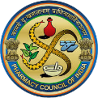 | Geethanjali College of Pharmacy  UGC AUTONOMOUS |  | 
Approved by PCI New Delhi, Affiliated to JNTUH, Accredited by NAAC with an A+ Grade,
Accredited by NBA (B. Pharmacy) Recognized by DSIR’s SIRO and ISO 9001:2015 Certified.
Cheeryal (V), Keesara (M), Medchal-Malkajgiri Dist.- Telangana State- 501303.

Mind Map
Date: 18.07.2026
Name of the Faculty: Mr. Kishor Kumar Reddy Designation: Associate Professor
Department: Pharmaceutics
Subject: Physical Pharmaceutics-II Class: B. Pharm II Year
Unit /Topic: Emulsions
Timings: 1:50 pm to 2: 40 pm

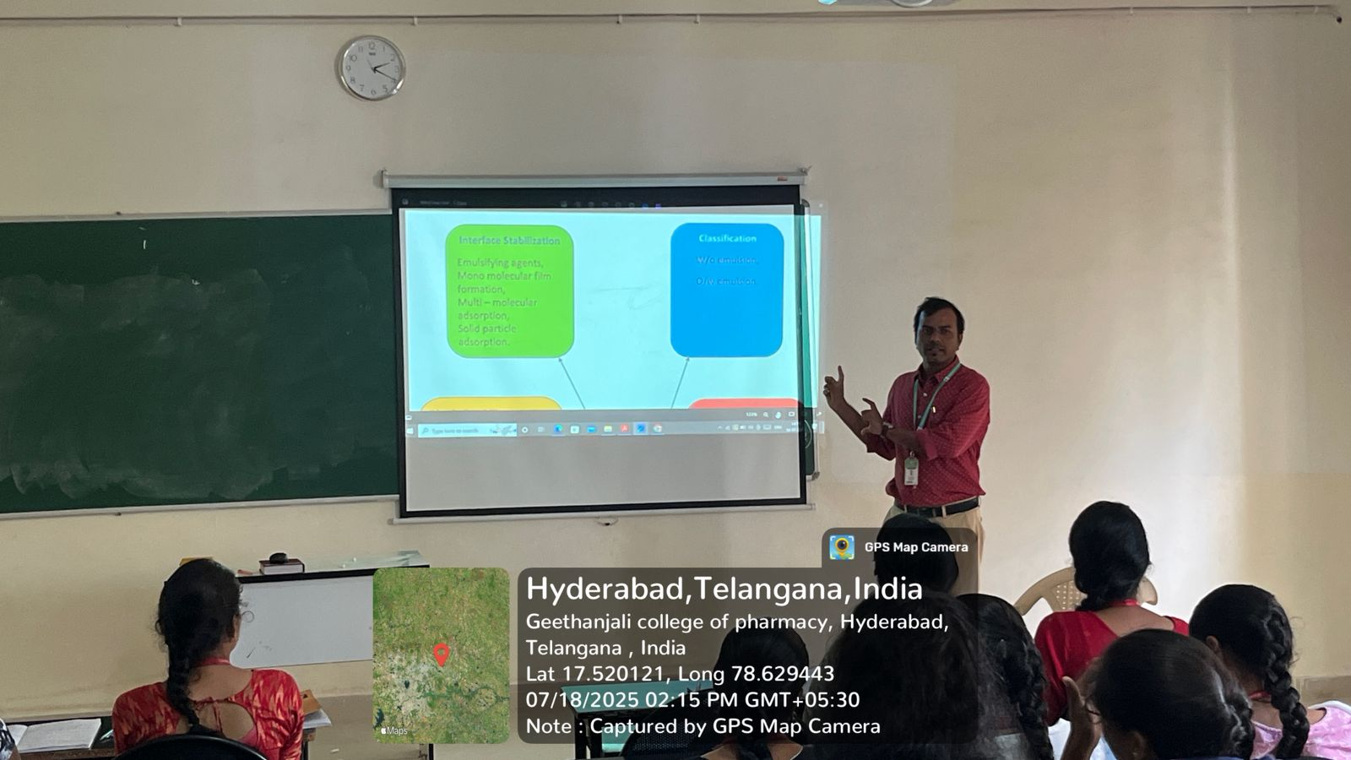

FACULTY HOD PRINCIPAL

Geethanjali College of Pharmacy

UGC AUTONOMOUS
Approved by PCI New Delhi, Affiliated to JNTUH, Accredited by NAAC with an A+ Grade,
Accredited by NBA (B. Pharmacy) Recognized by DSIR’s SIRO and ISO 9001:2015 Certified.
Cheeryal (V), Keesara (M), Medchal-Malkajgiri Dist.- Telangana State- 501303.
Team based Learning
Date: 29.07.2026
Name of the Faculty: Dr. P. Naga chandrika Designation: Associate Professor
Department: Pharmaceutics
Subject: Industrial Pharmacy-II Class: B. Pharm IV Year- II Sem
Unit /Topic: Pk Solver explanation
Timings: 9:50 am to 10: 40 am

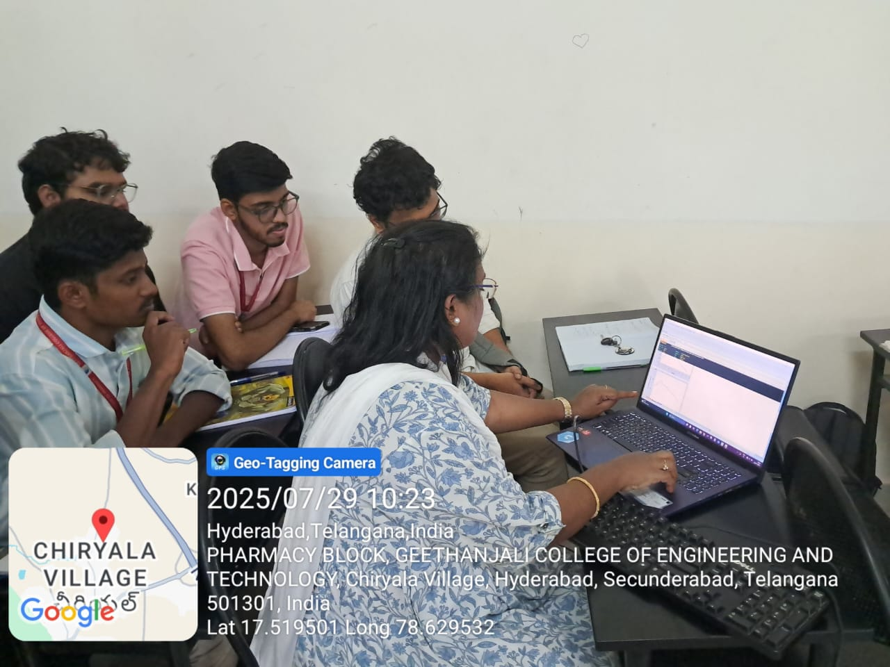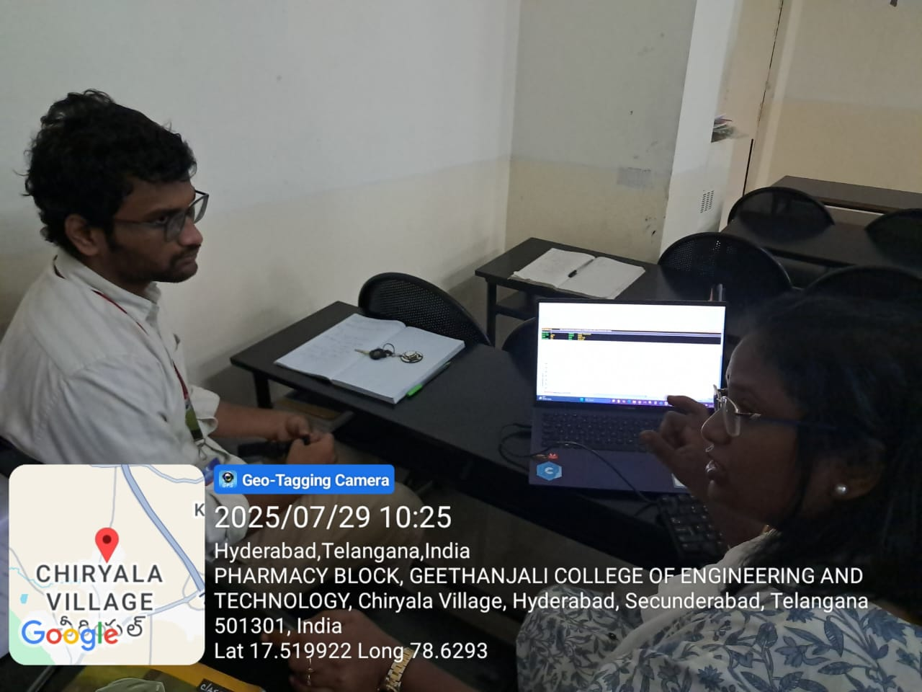

FACULTY HOD PRINCIPAL

Geethanjali College of Pharmacy
Approved by PCI New Delhi, Permanently Affiliated to JNTUH
Accredited by NBA (B. Pharmacy) & Accredited by NAAC (A+)
Recognized by DSIR-SIRO & HI/BI of MSME,Certified by ISO 9001:2015
Cheeryal (V), Keesara (M), Medchal-Malkajgiri Dist., Telangana State- 501303

Simulation based Learning -Ex-Pharm Series Simulation Software
Date: 03.04.2026
Name of the Faculty: Mrs L. Saritha Designation: Asst Professor Department: Pharmacology
Subject: Pharmacology-II Class: B.Pharm III Year-I Sem
Unit /Topic: Bioassays
Timings: 1:00 pm to 3: 20 pm
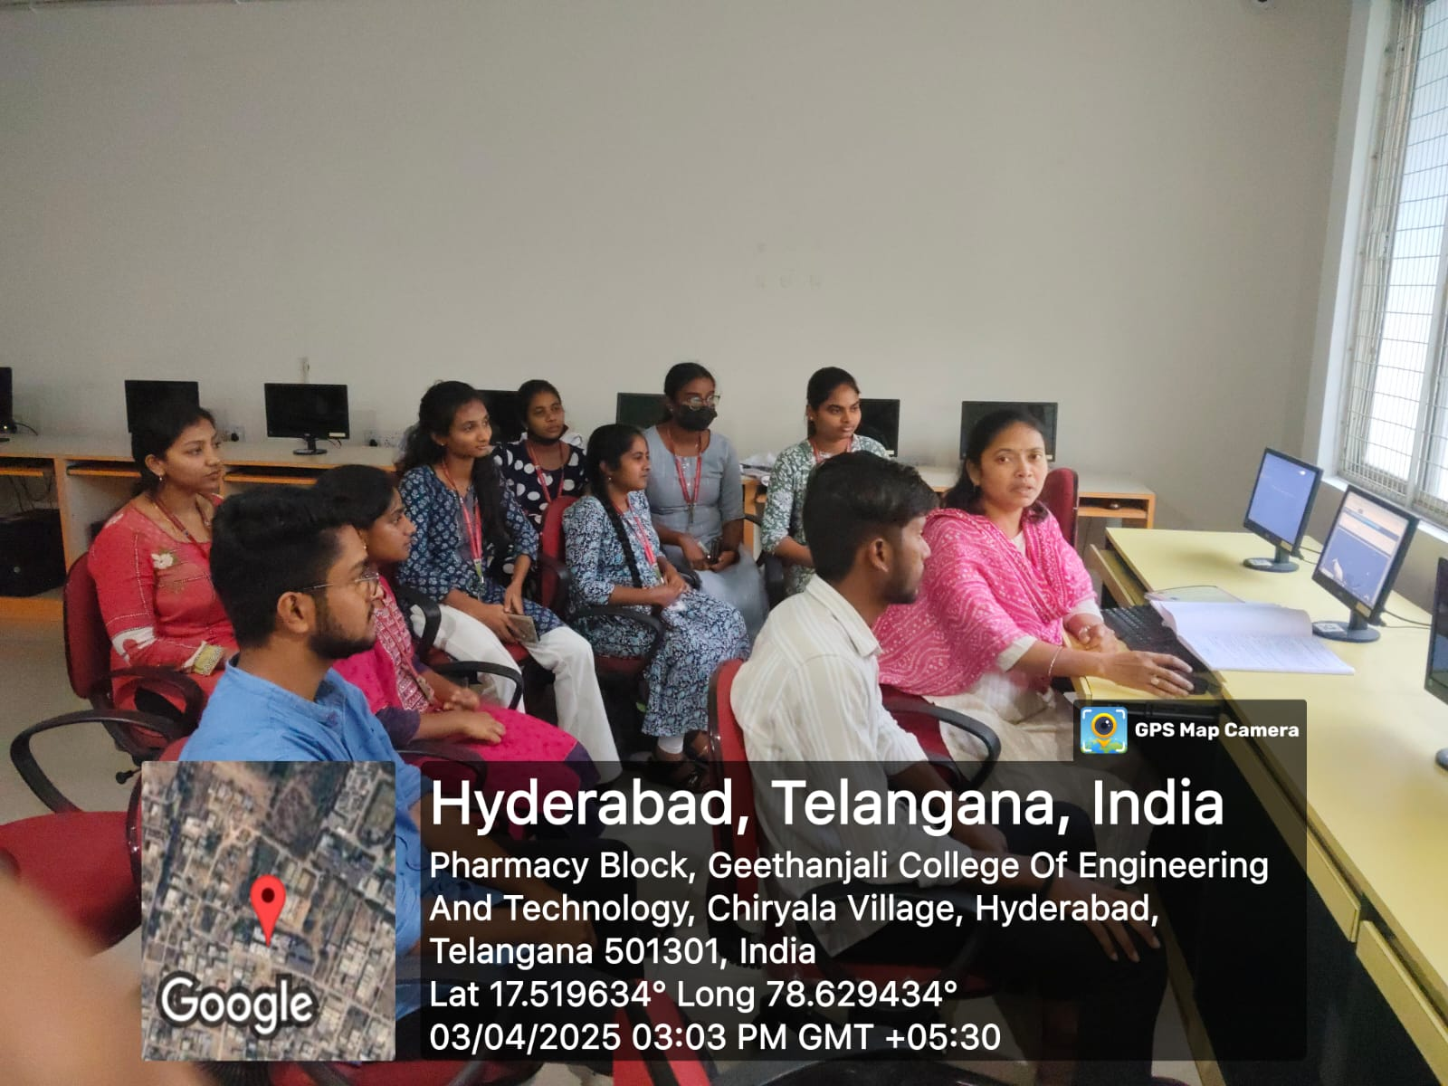

FACULTY HOD PRINCIPAL

Geethanjali College of Pharmacy
Approved by PCI New Delhi, Permanently Affiliated to JNTUH
Accredited by NBA (B. Pharmacy) & Accredited by NAAC (A+)
Recognized by DSIR-SIRO & HI/BI of MSME,Certified by ISO 9001:2015
Cheeryal (V), Keesara (M), Medchal-Malkajgiri Dist., Telangana State- 501303

Flipped Classroom
Date: 07.05.2026
Name of the Faculty: Dr. A. Madhavi Designation: Associate Professor
Department: Pharmaceutical Analysis
Presentation: Student Presentation
Subject: Pharmaceutical Biochemistry Class: B. Pharm II Year-I Sem
Unit /Topic: Ketone bodies formation and Utilization
Timings: 10:40 am to11:30 am
Description: Students are encouraged to give oral presentation and have thorough knowledge of definition, pathogenesis, signs and symptoms of diseases
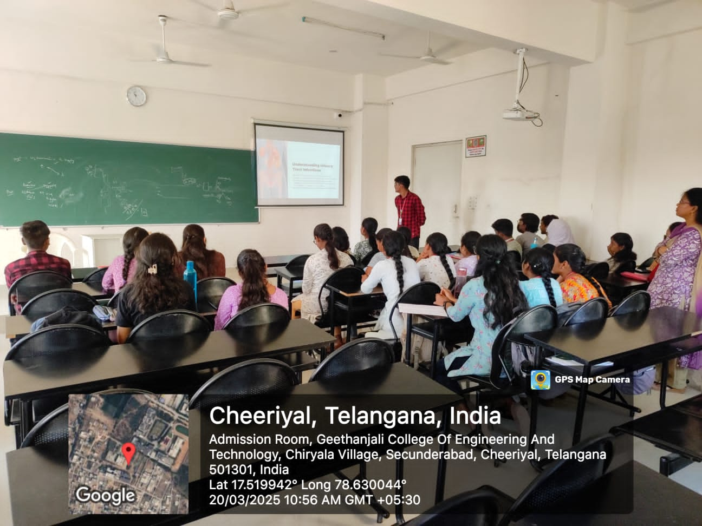

FACULTY HOD PRINCIPAL

Geethanjali College of Pharmacy
Approved by PCI New Delhi, Permanently Affiliated to JNTUH
Accredited by NBA (B. Pharmacy) & Accredited by NAAC (A+)
Recognized by DSIR-SIRO & HI/BI of MSME,Certified by ISO 9001:2015
Cheeryal (V), Keesara (M), Medchal-Malkajgiri Dist., Telangana State- 501303

Lab Demonstration GraphPad (TLP method/ ICT Tool)
Date: 28.07.2025
Name of the Faculty: Mrs. P. Naga Chandrika Designation: Asst Professor
Department: Pharmaceutics
Presentation: Student Presentation
Subject: Biopharmaceutics and pharmacokinetics Lab Class: B.Pharm III Year-II Sem
Unit /Topic: Estimation of Pharmacokinetic parameter of one compartment open Model of IV Infusion
Timings: 1:00 pm to 3: 20 pm
Description: Students are encouraged to give oral presentation.
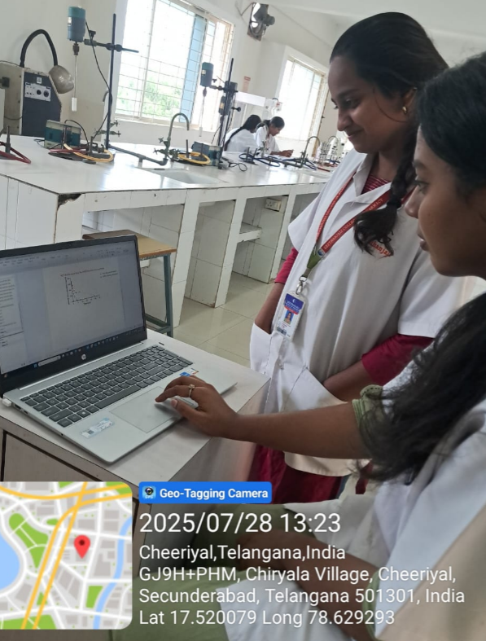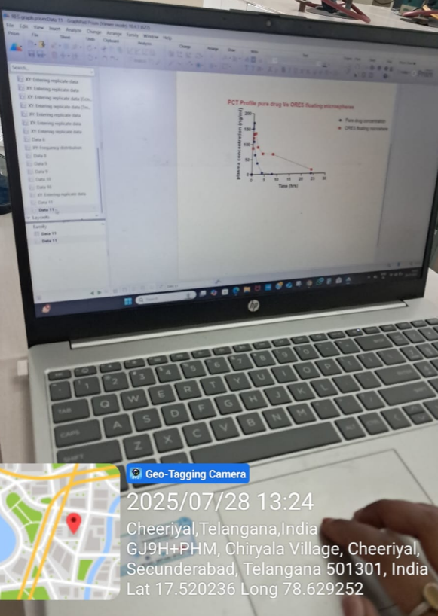

FACULTY HOD PRINCIPAL

Geethanjali College of Pharmacy
Approved by PCI New Delhi, Permanently Affiliated to JNTUH
Accredited by NBA (B. Pharmacy) & Accredited by NAAC (A+)
Recognized by DSIR-SIRO & HI/BI of MSME,Certified by ISO 9001:2015
Cheeryal (V), Keesara (M), Medchal-Malkajgiri Dist., Telangana State- 501303

Blended Learning PPT-BlackBoard
Date: 13.04.2026
Name of the Faculty: V. Shalini Designation: Associate Professor

Department: Pharmacology

Subject: Pharmacology-III Class: B.Pharm III Year-II Sem

Unit /Topic: Fluoroquinolones

Timings: 1:50 pm to 2:40 pm

Description: students are encouraged to give oral presentation.

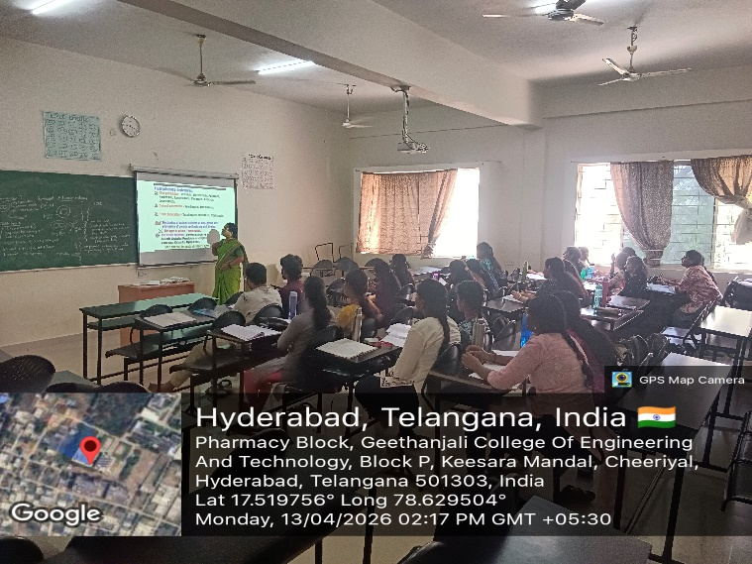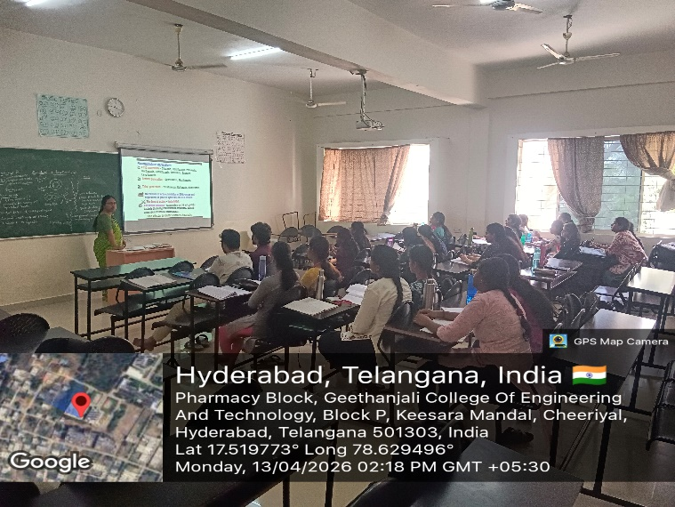

FACULTY HOD PRINCIPAL

Geethanjali College of Pharmacy
Approved by PCI New Delhi, Permanently Affiliated to JNTUH
Accredited by NBA (B. Pharmacy) & Accredited by NAAC (A+)
Recognized by DSIR-SIRO & HI/BI of MSME,Certified by ISO 9001:2015
Cheeryal (V), Keesara (M), Medchal-Malkajgiri Dist., Telangana State- 501303

QUIZ
Date: 02.12.2025
Name of the Faculty: Dr. P. Naga chandrika Designation: Associate Professor
Department: Pharmaceutics
Subject: Industrial Pharmacy-II Class: B. Pharm IV Year- II Sem
Unit /Topic: Mid-I Syllabus
Timings: 1:00 pm to 1: 50 pm

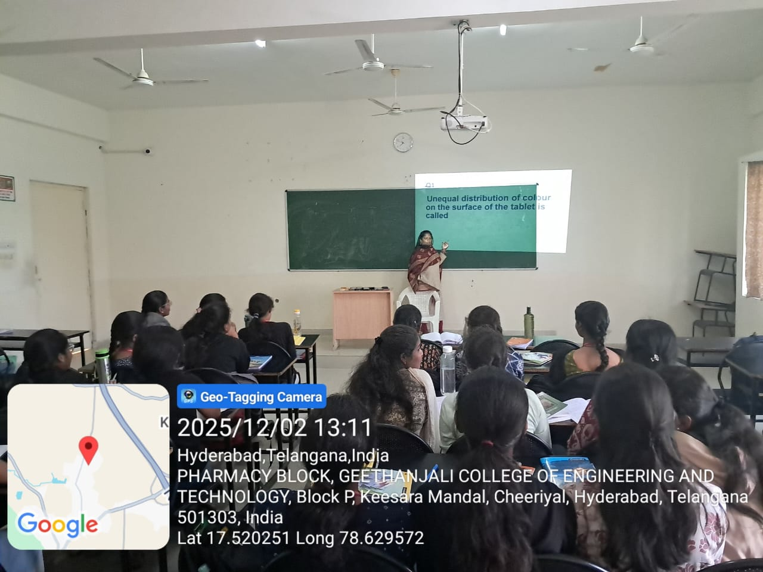

FACULTY HOD PRINCIPAL

Geethanjali College of Pharmacy
Approved by PCI New Delhi, Permanently Affiliated to JNTUH
Accredited by NBA (B. Pharmacy) & Accredited by NAAC (A+)
Recognized by DSIR-SIRO & HI/BI of MSME,Certified by ISO 9001:2015
Cheeryal (V), Keesara (M), Medchal-Malkajgiri Dist., Telangana State- 501303

Problem based Learning
Date: 05.05.2025
Name of the Faculty: K. Swapna Designation: Asst Professor Department: S & H
Subject: Biostatistics & Research Methodology Class: B. Pharm IV Year-II Sem
Unit /Topic: Non-Parametric Tests
Timings: 1:50 pm to 2:40 pm

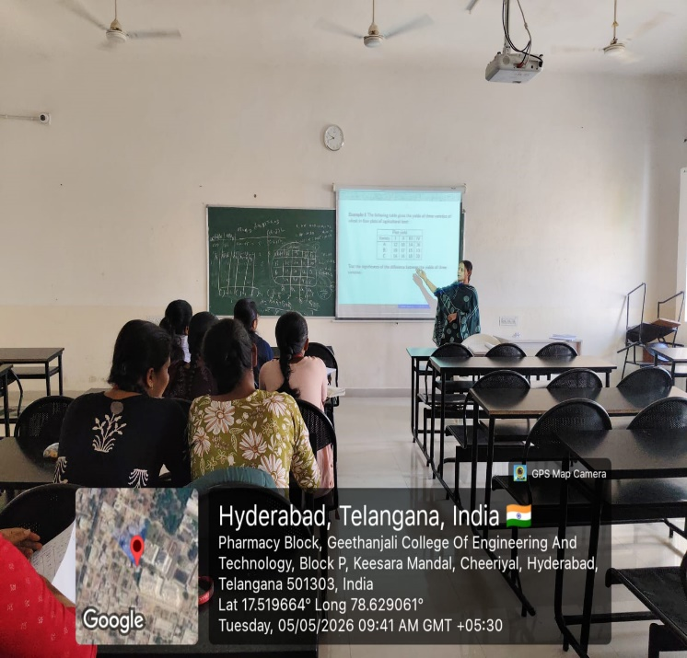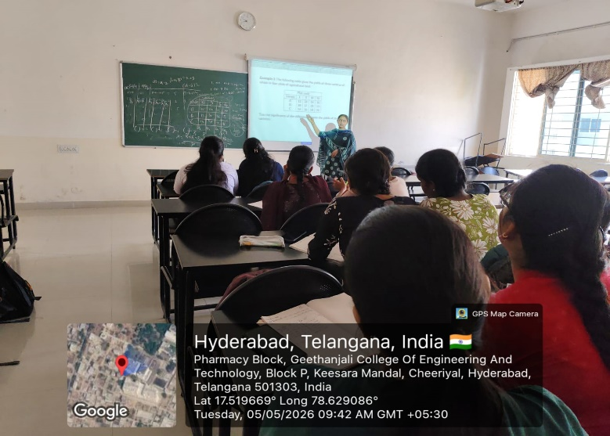

FACULTY HOD PRINCIPAL

Geethanjali College of Pharmacy
Approved by PCI New Delhi, Permanently Affiliated to JNTUH
Accredited by NBA (B. Pharmacy) & Accredited by NAAC (A+)
Recognized by DSIR-SIRO & HI/BI of MSME,Certified by ISO 9001:2015
Cheeryal (V), Keesara (M), Medchal-Malkajgiri Dist., Telangana State- 501303

Problem based Learning-Smart Board
Date: 01.11.2025
Name of the Faculty: K. Swapna Designation: Asst Professor Department: S & H
Subject: Biostatistics & Research Methodology Class: B. Pharm IV Year-II Sem
Unit /Topic: Non-Parametric Tests
Timings: 9:50 am to 10:40 am

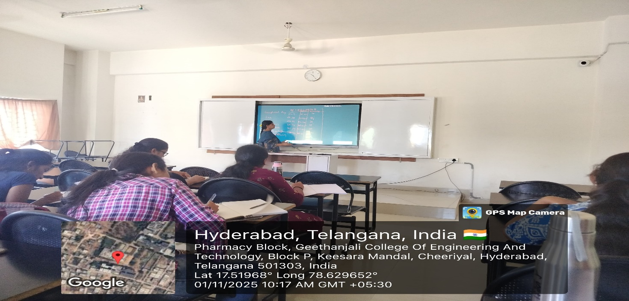

FACULTY HOD PRINCIPAL

Geethanjali College of Pharmacy
Approved by PCI New Delhi, Permanently Affiliated to JNTUH
Accredited by NBA (B. Pharmacy) & Accredited by NAAC (A+)
Recognized by DSIR-SIRO & HI/BI of MSME,Certified by ISO 9001:2015
Cheeryal (V), Keesara (M), Medchal-Malkajgiri Dist., Telangana State- 501303

Simulation based Learning -Ex-Pharm Series Simulation Software
Date: 29.12.2025
Name of the Faculty: Mrs V.Shalini Designation: Associate Professor Department: Pharmacology
Subject: Pharmacology-II Class: B.Pharm III Year-I Sem
Unit /Topic: Dose Response Curve
Timings: 1:00 pm to 3: 20 pm

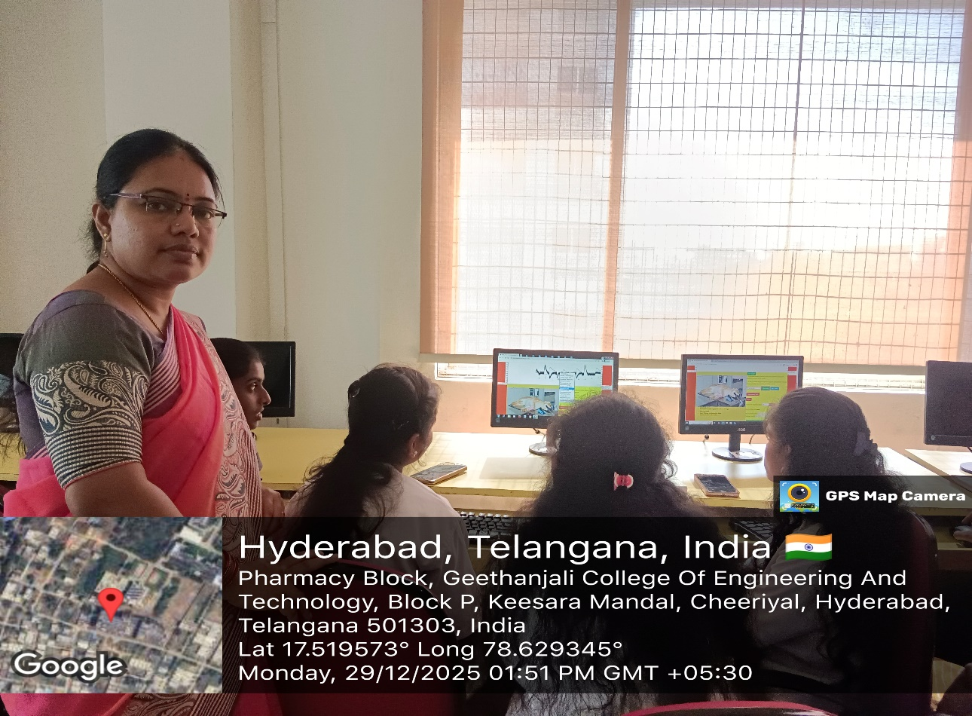

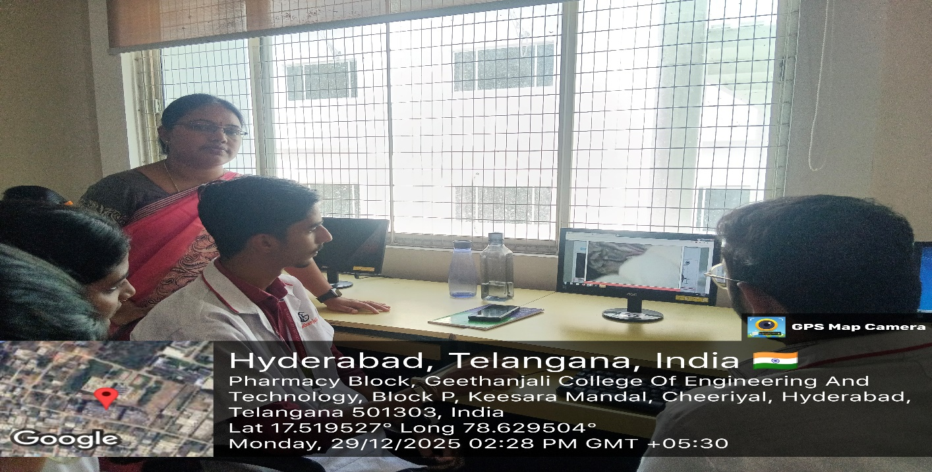

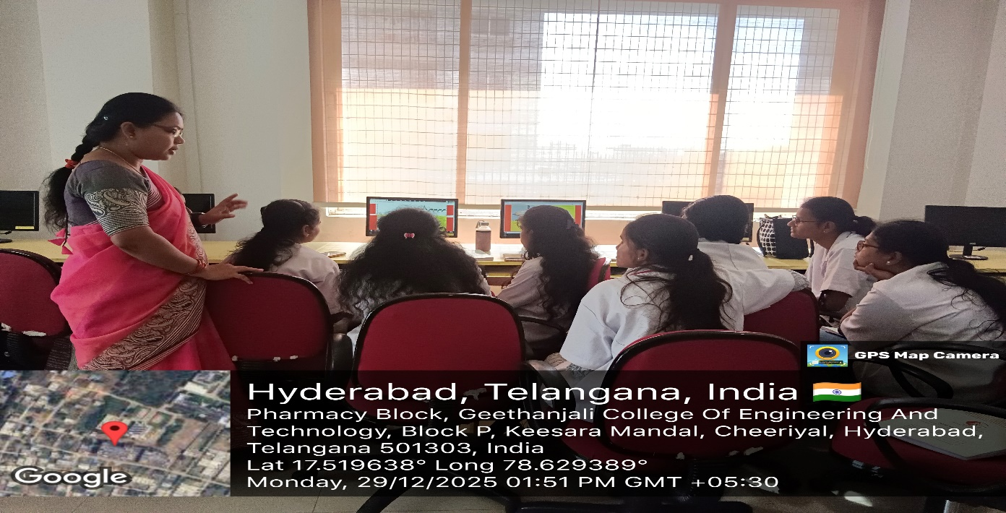

FACULTY HOD PRINCIPAL

Geethanjali College of Pharmacy
Approved by PCI New Delhi, Permanently Affiliated to JNTUH
Accredited by NBA (B. Pharmacy) & Accredited by NAAC (A+)
Recognized by DSIR-SIRO & HI/BI of MSME,Certified by ISO 9001:2015
Cheeryal (V), Keesara (M), Medchal-Malkajgiri Dist., Telangana State- 501303

Hands-on Training-Youtube
Date: 27.03.2025
Name of the Faculty: Mrs. D. Ashlesha Designation: Asst Professor
Department: Pharmaceutical Analysis
Subject: Instrumental Methos of Analysis Class: B. Pharm IV Year- II Sem
Unit /Topic: Estimation of Dextrose by Colorimetry
Timings: 1:00 pm to 3:20 pm
Description: students are encouraged to give demonstration.
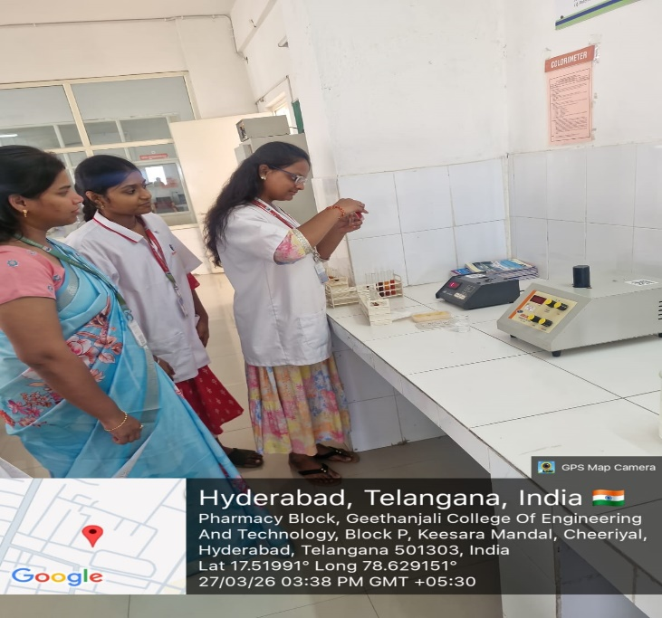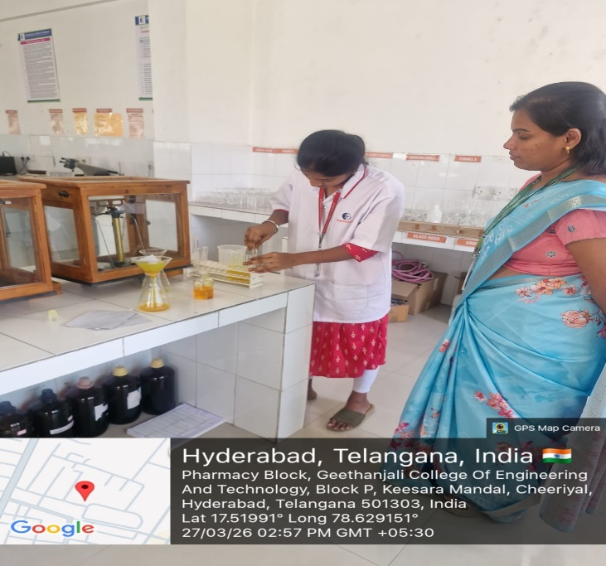

FACULTY HOD PRINCIPAL

Geethanjali College of Pharmacy
Approved by PCI New Delhi, Permanently Affiliated to JNTUH
Accredited by NBA (B. Pharmacy) & Accredited by NAAC (A+)
Recognized by DSIR-SIRO & HI/BI of MSME,Certified by ISO 9001:2015
Cheeryal (V), Keesara (M), Medchal-Malkajgiri Dist., Telangana State- 501303

Lab based Learning
Date: 27.04.2026
Name of the Faculty: Mrs. M. Sreevidhya Designation: Asst Professor Department: Pharmacology
Subject: Human Anatomy, Physiology and Pathophysiology-I Class: B. Pharmacy I Year II sem
Unit /Topic: Determination of Bleeding time
Timings: 12:10 pm to 3: 30 pm

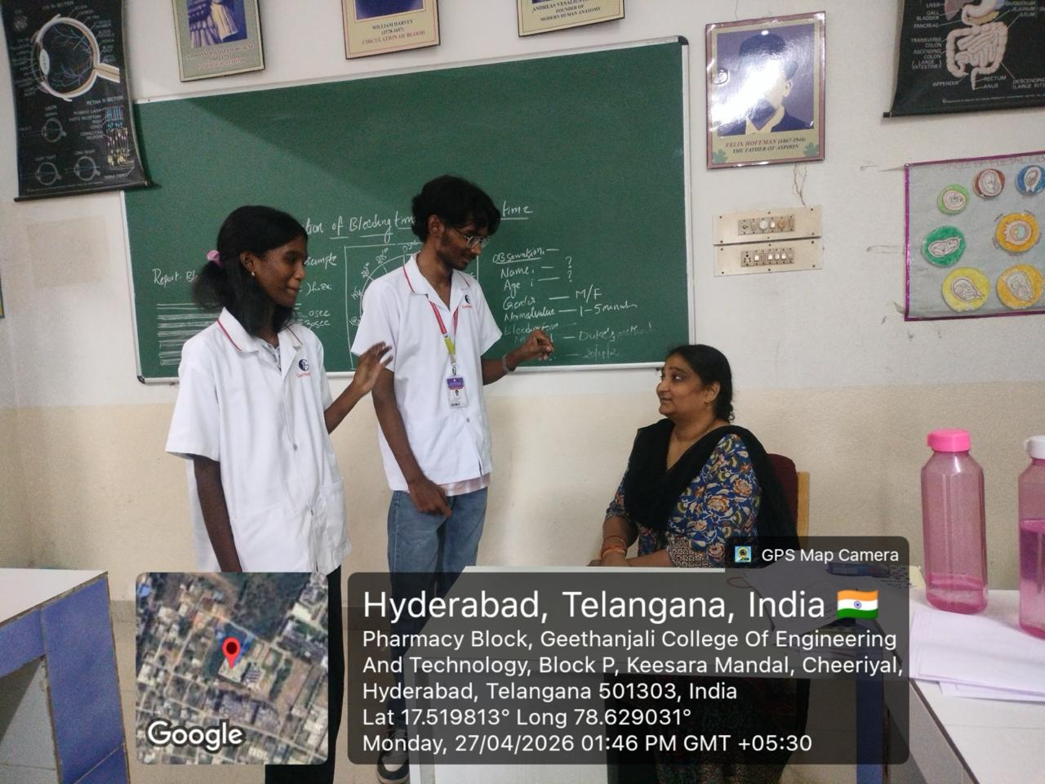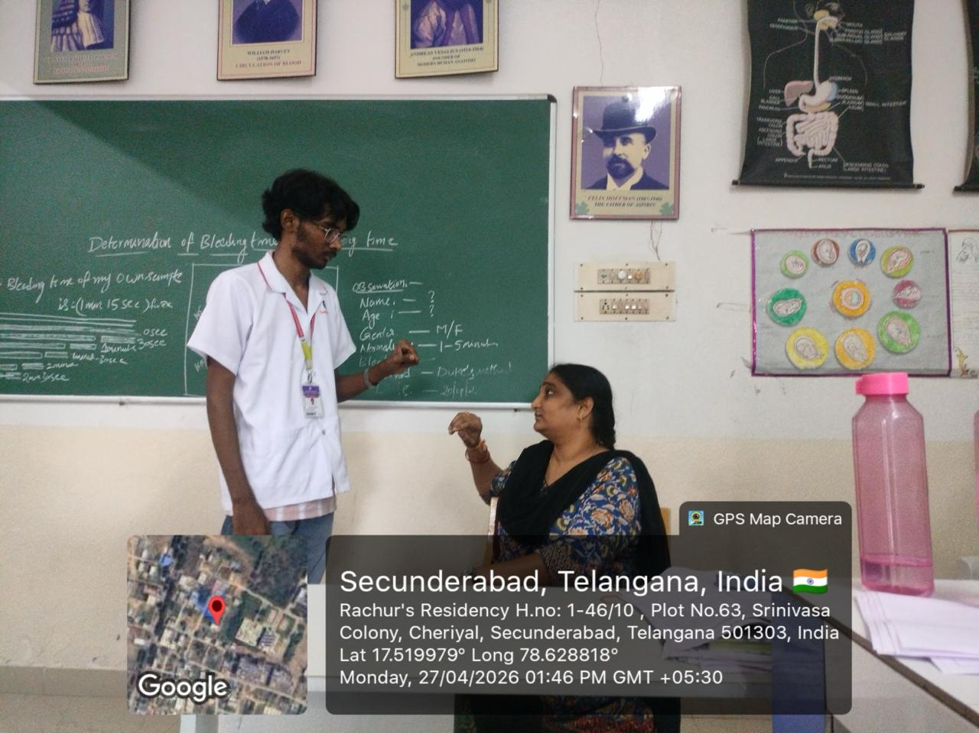

FACULTY HOD PRINCIPAL

Geethanjali College of Pharmacy
Approved by PCI New Delhi, Permanently Affiliated to JNTUH
Accredited by NBA (B. Pharmacy) & Accredited by NAAC (A+)
Recognized by DSIR-SIRO & HI/BI of MSME,Certified by ISO 9001:2015
Cheeryal (V), Keesara (M), Medchal-Malkajgiri Dist., Telangana State- 501303

Ex-Pharma Simulation Software (TLP method/ ICT Tool)
Date: 03.04.2025
Name of the Faculty: L. Saritha Designation: Asst Professor Department: Pharmacology
Presentation: Ex-Pharma Software-Animal Simulation
Subject: Pharmacology-II Class: B.Pharmacy III Year I sem
Unit /Topic: DRC of Acetylcholine
Timings: 12:10 pm to 3: 30 pm

FACULTY HOD PRINCIPAL

Geethanjali College of Pharmacy
Approved by PCI New Delhi, Permanently Affiliated to JNTUH
Accredited by NBA (B. Pharmacy) & Accredited by NAAC (A+)
Recognized by DSIR-SIRO & HI/BI of MSME,Certified by ISO 9001:2015
Cheeryal (V), Keesara (M), Medchal-Malkajgiri Dist., Telangana State- 501303

Flipped Classroom-YouTube
Date: 04.04.2026
Name of the Faculty: V. Shalini Designation: Associate Professor Department: Pharmacology
Subject: Pharmacology-III Class: B. Pharmacy III Year II Sem
Unit /Topic: General Principles of Chemotherapy
Timings: 9 :50 am to 10:40 am

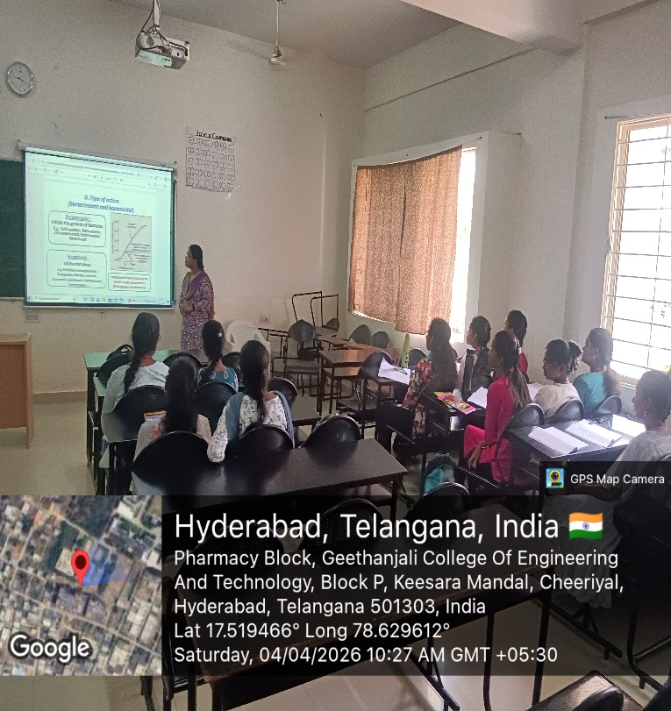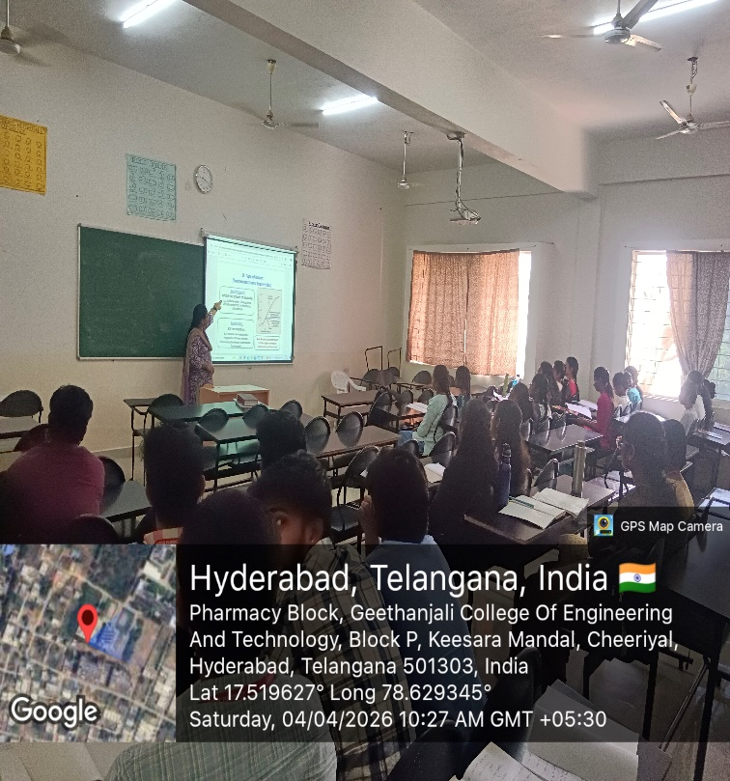

FACULTY HOD PRINCIPAL

Geethanjali College of Pharmacy
Approved by PCI New Delhi, Permanently Affiliated to JNTUH
Accredited by NBA (B. Pharmacy) & Accredited by NAAC (A+)
Recognized by DSIR-SIRO & HI/BI of MSME,Certified by ISO 9001:2015
Cheeryal (V), Keesara (M), Medchal-Malkajgiri Dist., Telangana State- 501303

Blended Learning -Blackboard and PPT Presentation
Date: 07.05.2025
Name of the Faculty: Mrs. M. Sreevidhya Designation: Asst Professor Department: Pharmacology
Presentation: PPT Presentation
Subject: Human Anatomy, Physiology and Pathophysiology-I
Class: B. Pharmacy I Year II sem
Unit /Topic: Osteoporosis-Pathogenesis
Timings: 9:50 am to 10: 40 am

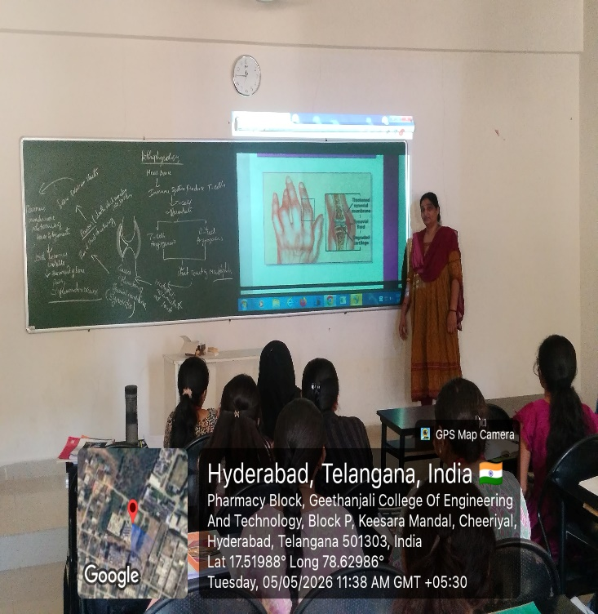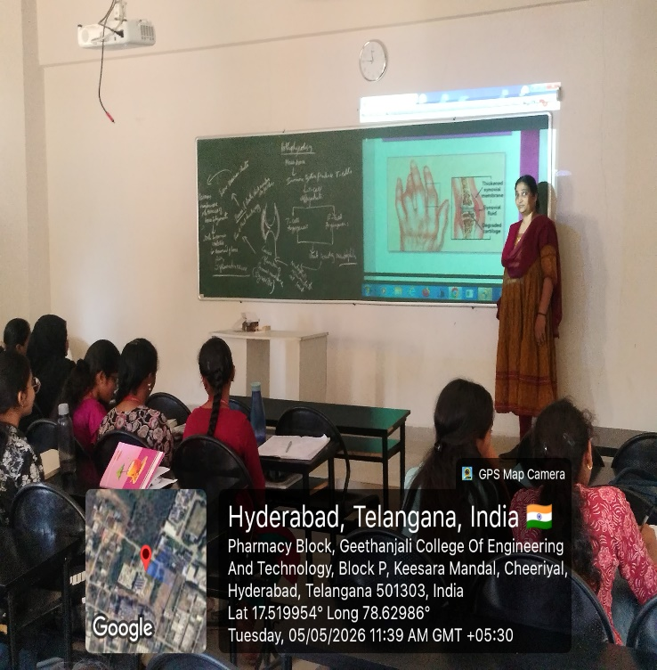

FACULTY HOD PRINCIPAL

Geethanjali College of Pharmacy
Approved by PCI New Delhi, Permanently Affiliated to JNTUH
Accredited by NBA (B. Pharmacy) & Accredited by NAAC (A+)
Recognized by DSIR-SIRO & HI/BI of MSME,Certified by ISO 9001:2015
Cheeryal (V), Keesara (M), Medchal-Malkajgiri Dist., Telangana State- 501303

Hands-on-Training
Date: 05.05.2026
Name of the Faculty: Mrs. P. Naga Chandrika Designation: Asst Professor
Department: Pharmaceutics
Presentation: Student Participation
Subject: Biopharmaceutics and pharmacokinetics Lab Class: B.Pharm III Year-II Sem
Unit /Topic: Dissolution Studies
Timings: 1:00 pm to 3: 20 pm
Description: Students are encouraged to give oral presentation.
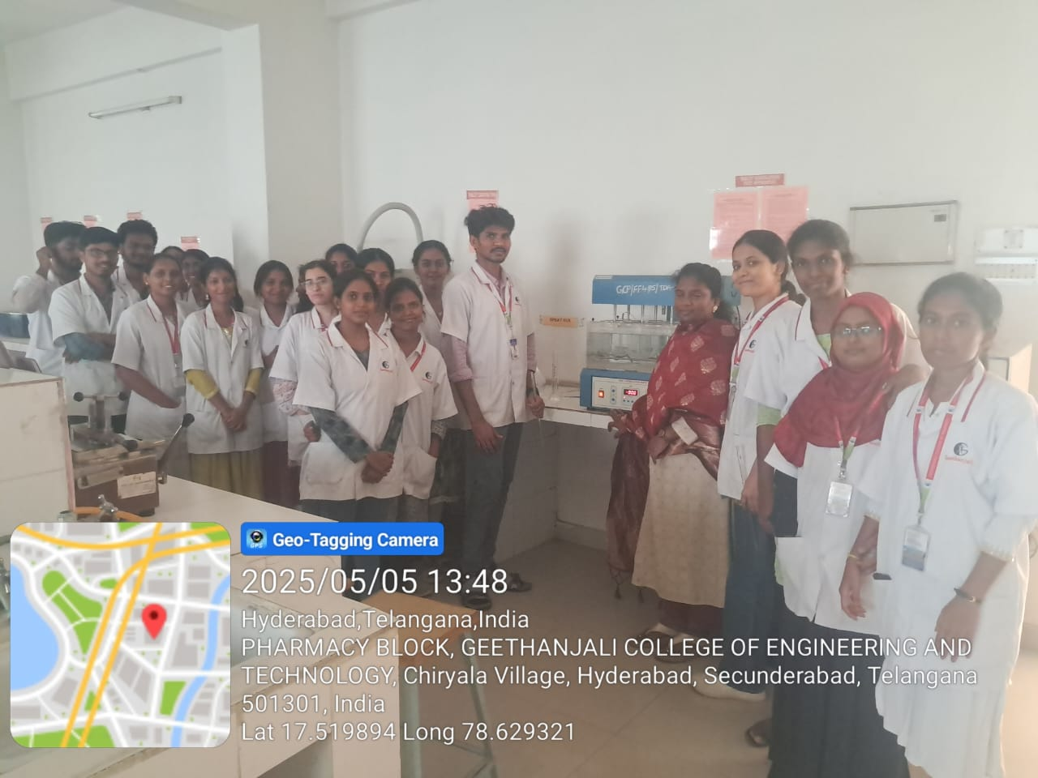

FACULTY HOD PRINCIPAL

Geethanjali College of Pharmacy
Approved by PCI New Delhi, Permanently Affiliated to JNTUH
Accredited by NBA (B. Pharmacy) & Accredited by NAAC (A+)
Recognized by DSIR-SIRO & HI/BI of MSME,Certified by ISO 9001:2015
Cheeryal (V), Keesara (M), Medchal-Malkajgiri Dist., Telangana State- 501303

QUIZ
Date: 07.05.2025
Name of the Faculty: Mrs. M. Sreevidhya Designation: Asst Professor Department: Pharmacology
Subject: Human Anatomy, Physiology and Pathophysiology-I
Class: B. Pharmacy I Year II sem
Unit /Topic: Types of Joints
Timings: 9:00 am to 9: 50 am
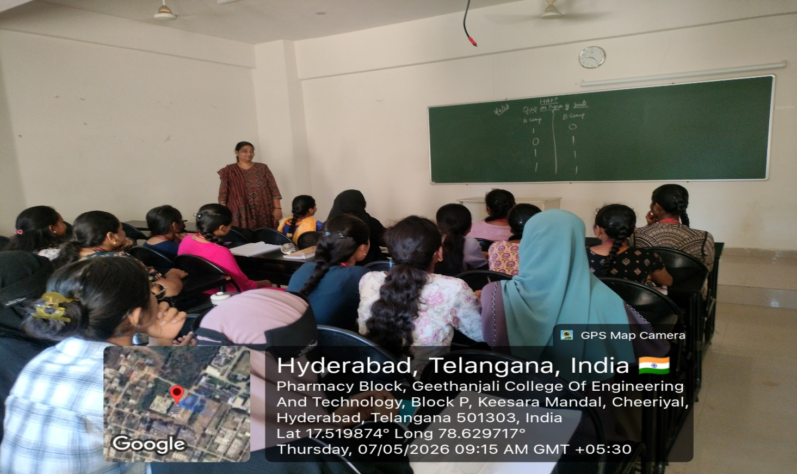

FACULTY HOD PRINCIPAL

Geethanjali College of Pharmacy
Approved by PCI New Delhi, Permanently Affiliated to JNTUH
Accredited by NBA (B. Pharmacy) & Accredited by NAAC (A+)
Recognized by DSIR-SIRO & HI/BI of MSME,Certified by ISO 9001:2015
Cheeryal (V), Keesara (M), Medchal-Malkajgiri Dist., Telangana State- 501303

Student Seminar Presentations-Smart Board
Date: 08.10.2025
Name of the Faculty: Mrs. S. Rani Designation: Asst Professor Department: Pharmaceutics
Presentation: Student Seminar Presentation
Subject: Biopharmaceutics and pharmacokinetics Class: B. Pharmacy III Year II sem
Unit /Topic: Mechanisms of Absorption
Timings: 10:40 am to 11: 30 am

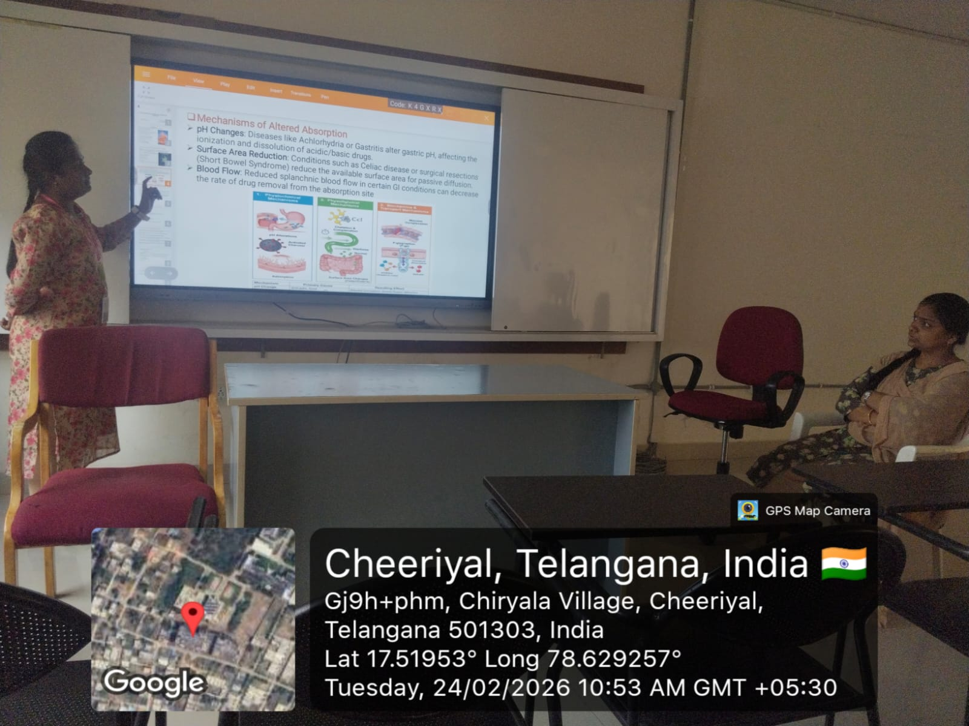

FACULTY HOD PRINCIPAL

Geethanjali College of Pharmacy
Approved by PCI New Delhi, Permanently Affiliated to JNTUH
Accredited by NBA (B. Pharmacy) & Accredited by NAAC (A+)
Recognized by DSIR-SIRO & HI/BI of MSME,Certified by ISO 9001:2015
Cheeryal (V), Keesara (M), Medchal-Malkajgiri Dist., Telangana State- 501303

Kahoot
Date: 06.05.2025
Name of the Faculty: K. Swapna Designation: Asst Professor Department: S & H
Subject: Biostatistics & Research Methodology Class: B. Pharm IV Year-II Sem
Unit /Topic: Students t test
Timings: 1:50 pm to 2:40 pm
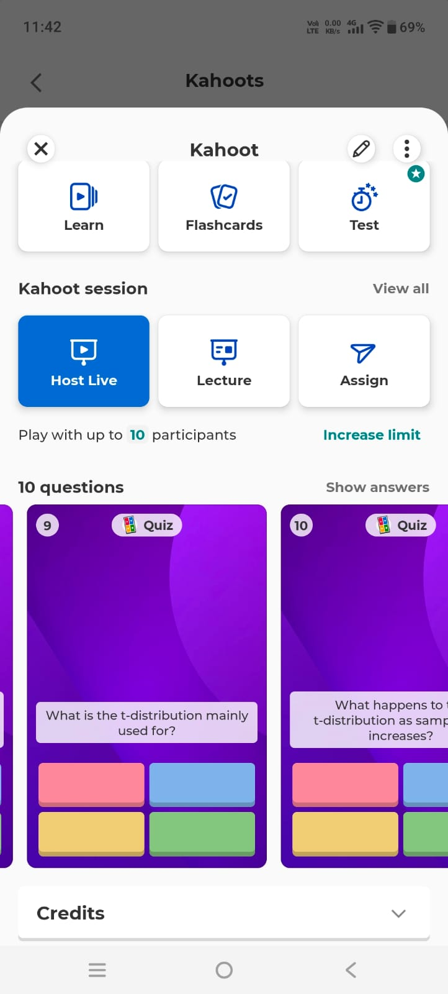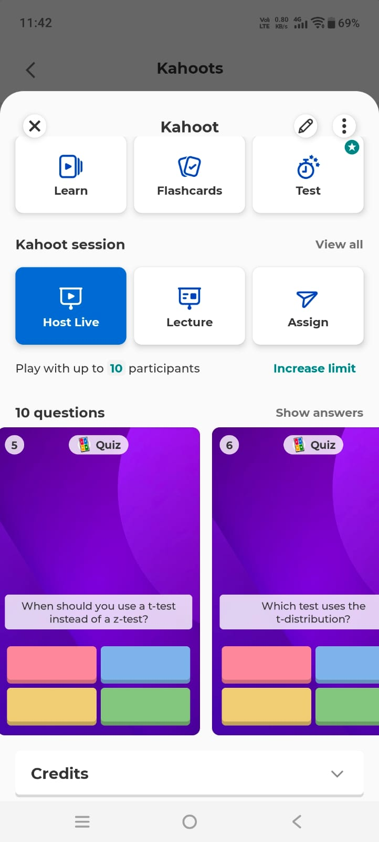

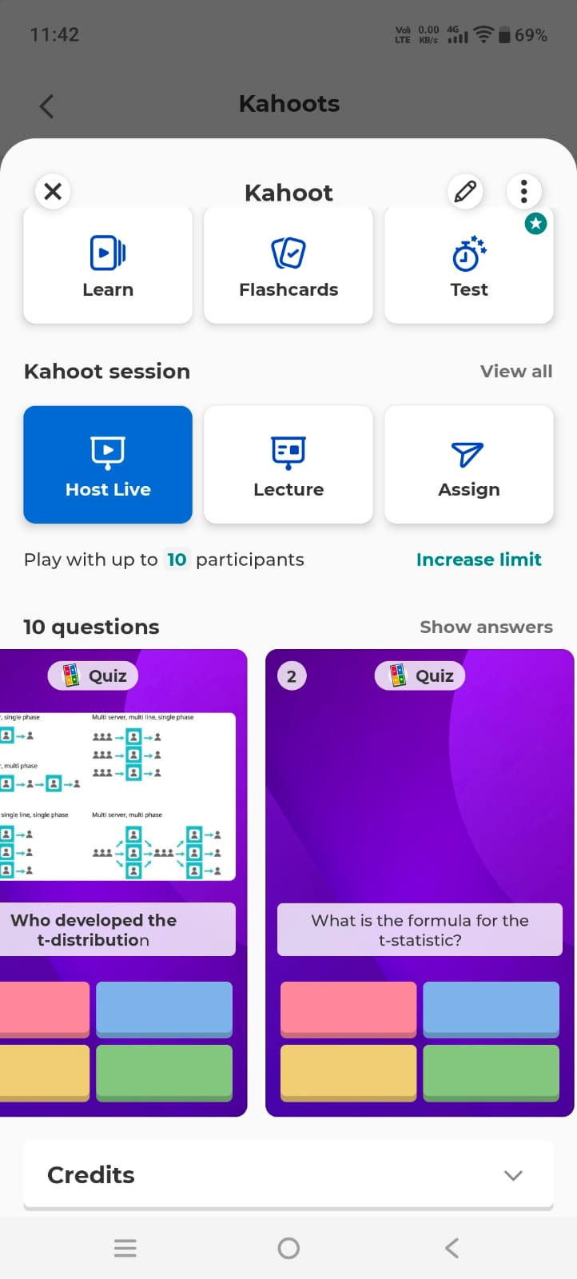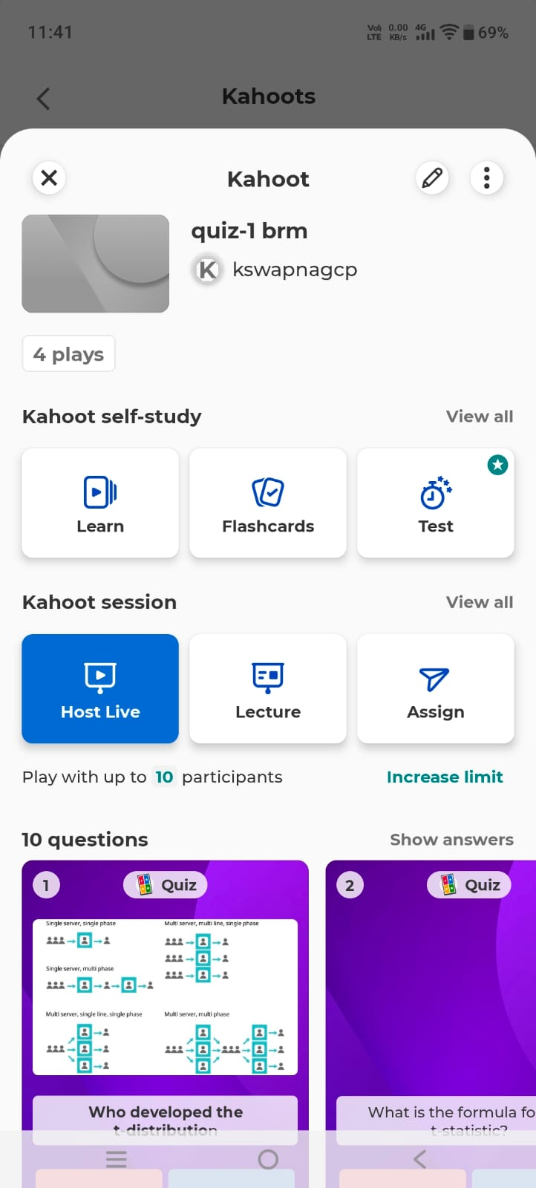
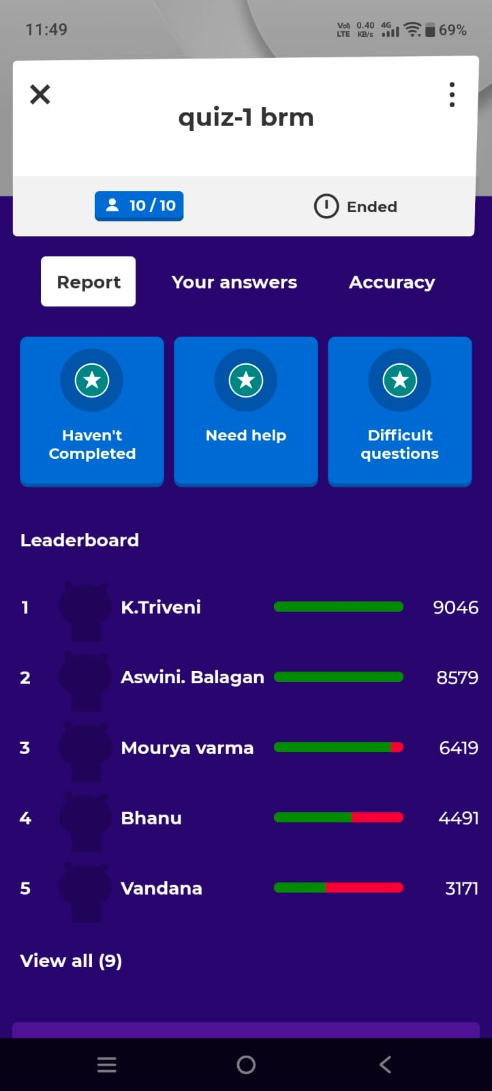

FACULTY HOD PRINCIPAL

Geethanjali College of Pharmacy
Approved by PCI New Delhi, Permanently Affiliated to JNTUH
Accredited by NBA (B. Pharmacy) & Accredited by NAAC (A+)
Recognized by DSIR-SIRO & HI/BI of MSME,Certified by ISO 9001:2015
Cheeryal (V), Keesara (M), Medchal-Malkajgiri Dist., Telangana State- 501303

Student Seminar Presentations-Smart Board
Date: 13.02.2026
Name of the Faculty: Mrs. S. Rani Designation: Asst Professor Department: Pharmaceutics
Presentation: Student Seminar Presentation
Subject: Biopharmaceutics and pharmacokinetics Class: B. Pharmacy III Year II sem
Unit /Topic: Bioequivalence Study
Timings: 9:00 am to 9: 50 am

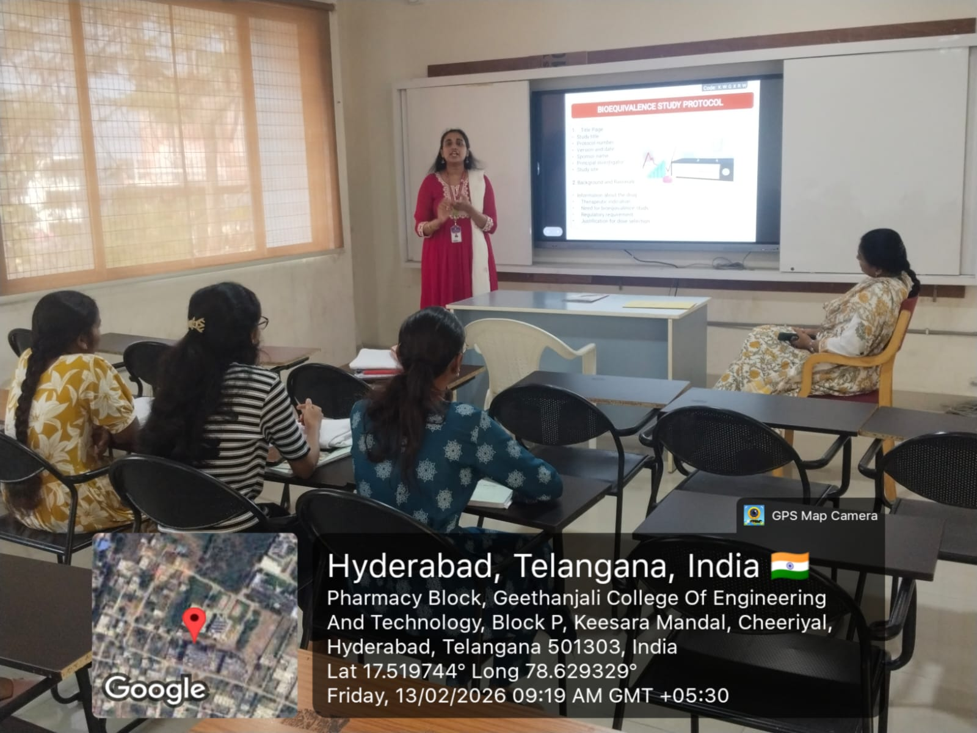

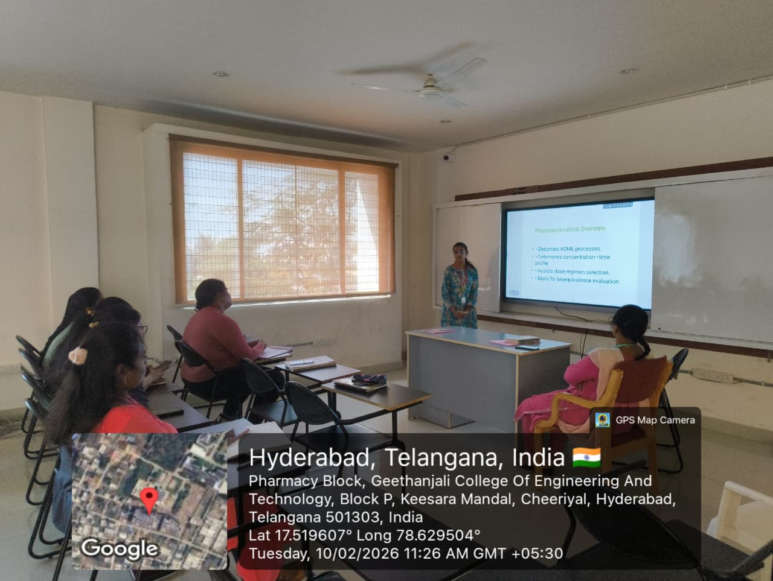

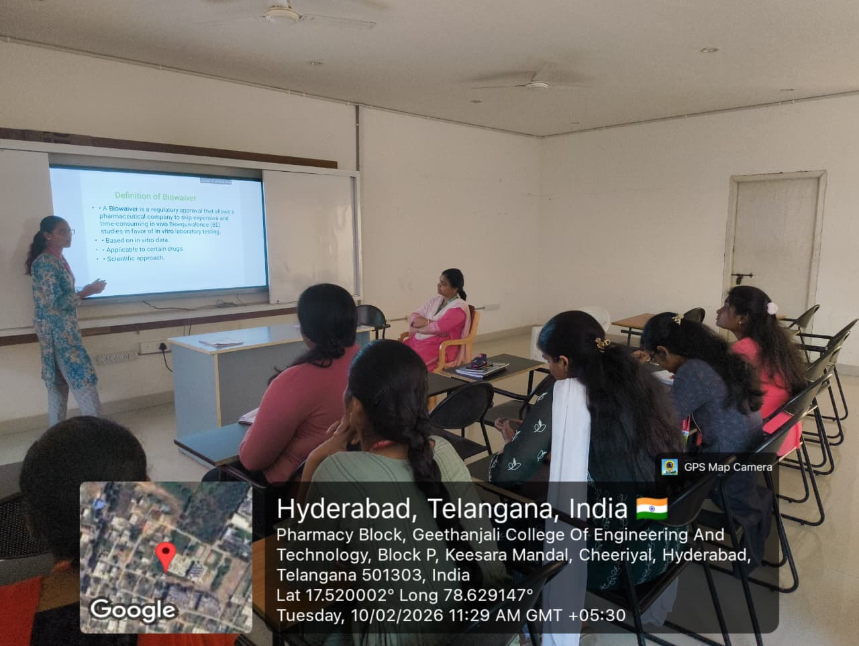

FACULTY HOD PRINCIPAL

Geethanjali College of Pharmacy
Approved by PCI New Delhi, Permanently Affiliated to JNTUH
Accredited by NBA (B. Pharmacy) & Accredited by NAAC (A+)
Recognized by DSIR-SIRO & HI/BI of MSME,Certified by ISO 9001:2015
Cheeryal (V), Keesara (M), Medchal-Malkajgiri Dist., Telangana State- 501303

PPT Presentations-Smart Board
Date: 28.03.2026
Name of the Faculty: Mrs. K. L. Rajitha Designation: Asst Professor
Department: Pharmaceutical Analysis
Subject: Pharmaceutical Biochemistry Class: B. Pharmacy I Year II sem
Unit /Topic: Glycolysis
Timings: 9:50 am to 10:40 am
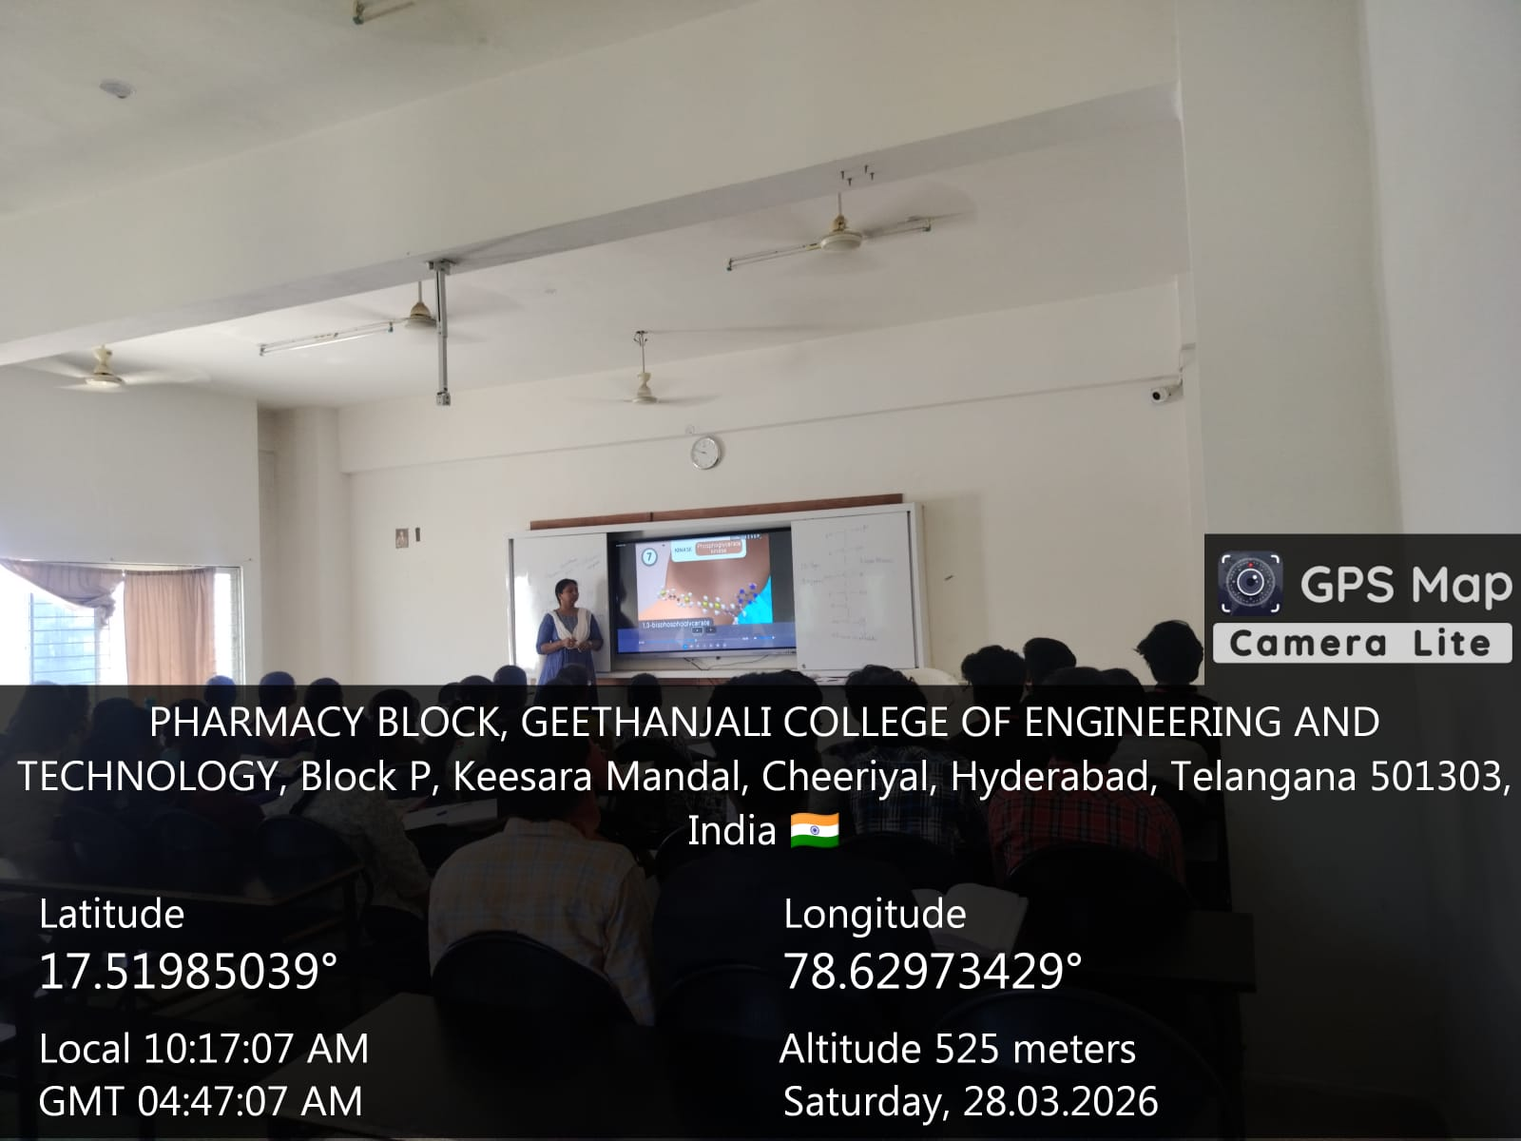

FACULTY HOD PRINCIPAL

Geethanjali College of Pharmacy
Approved by PCI New Delhi, Permanently Affiliated to JNTUH
Accredited by NBA (B. Pharmacy) & Accredited by NAAC (A+)
Recognized by DSIR-SIRO & HI/BI of MSME,Certified by ISO 9001:2015
Cheeryal (V), Keesara (M), Medchal-Malkajgiri Dist., Telangana State- 501303

Think-Pair-Share
Date: 06.05.2026
Name of the Faculty: V. Shalini Designation: Asst Professor Department: Pharmacology
Presentation: Student centric learning
Subject: Pharmacology Class: B. Pharmacy II Year II sem
Unit /Topic: CHF-Pathology
Timings: 9:00 am to 9:50 am

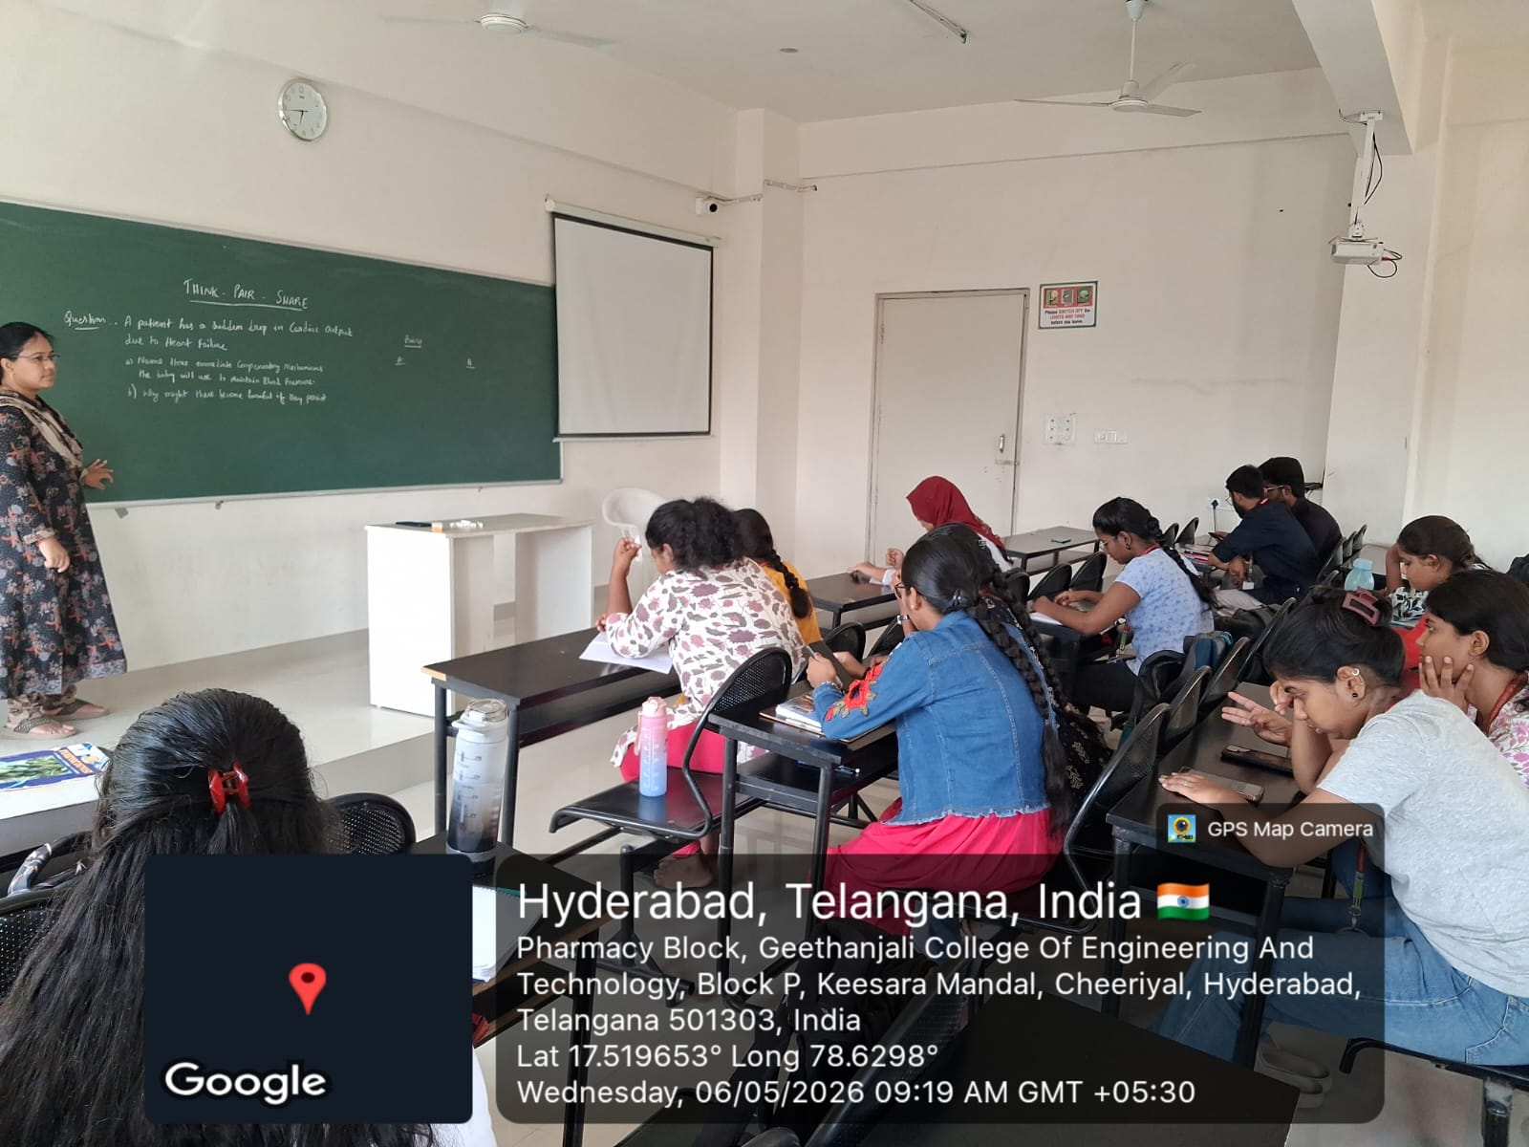

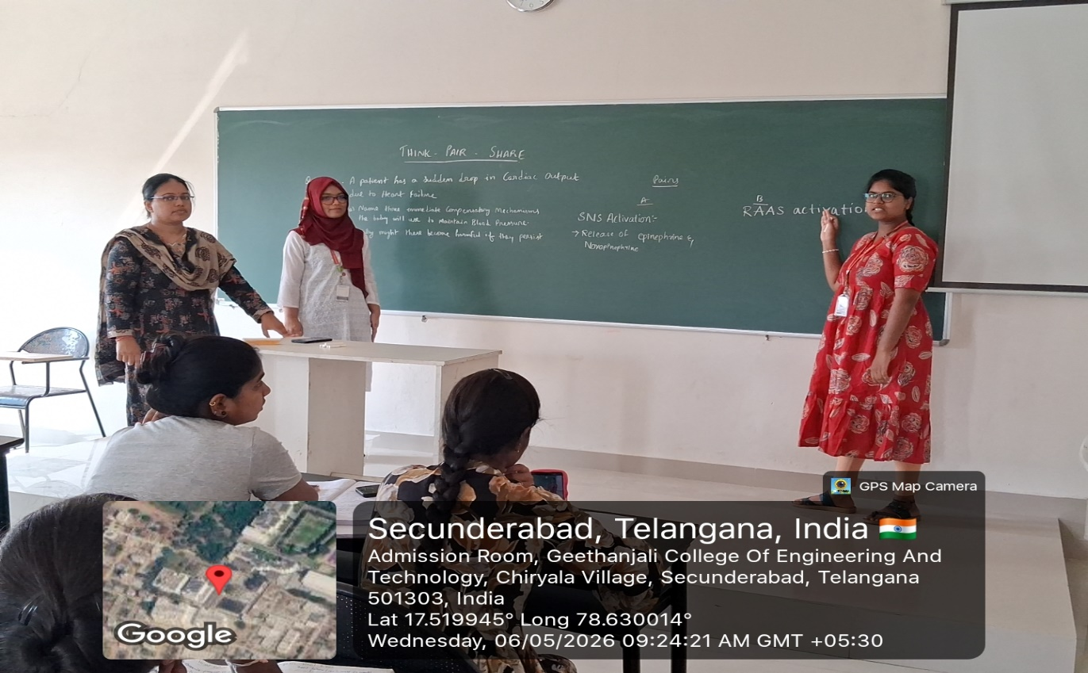

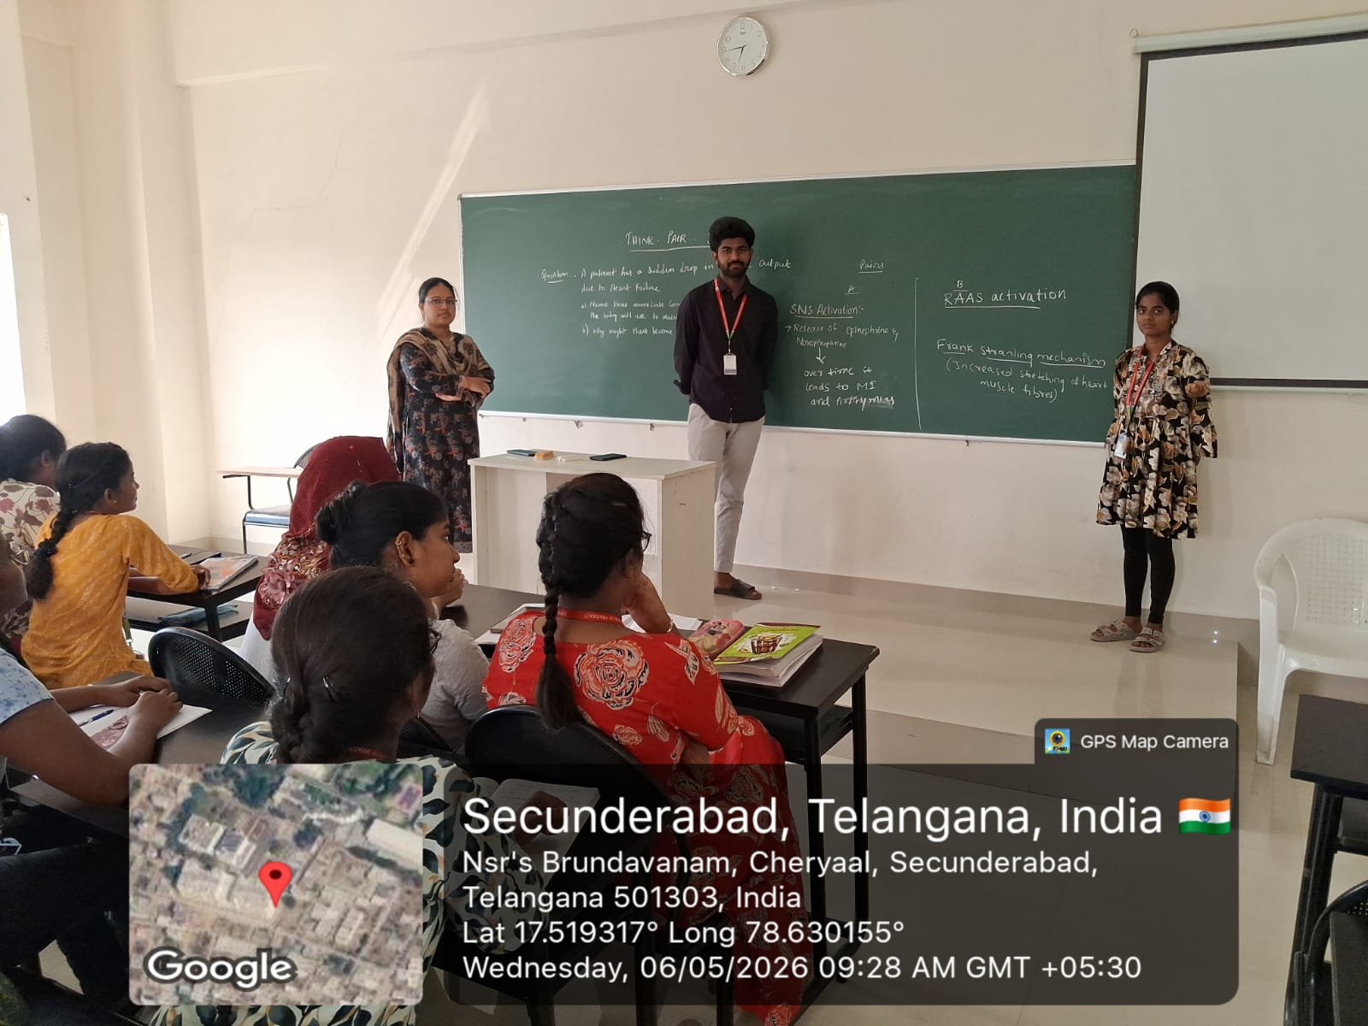

FACULTY HOD PRINCIPAL

Geethanjali College of Pharmacy
Approved by PCI New Delhi, Permanently Affiliated to JNTUH
Accredited by NBA (B. Pharmacy) & Accredited by NAAC (A+)
Recognized by DSIR-SIRO & HI/BI of MSME,Certified by ISO 9001:2015
Cheeryal (V), Keesara (M), Medchal-Malkajgiri Dist., Telangana State- 501303

Hands-on Training
Date: 25.07.2026
Name of the Faculty: Mrs. S. Rani Designation: Asst Professor Department: Pharmaceutics
Presentation: Hands-on Training
Subject: Biopharmaceutics and pharmacokinetics Class: B. Pharmacy III Year II sem
Unit /Topic: Dissolution Studies
Timings: 9:00 am to 12:10 am

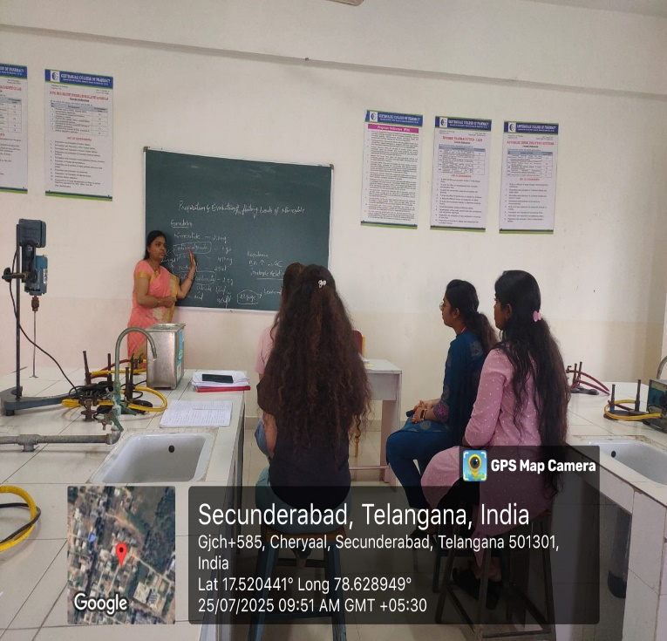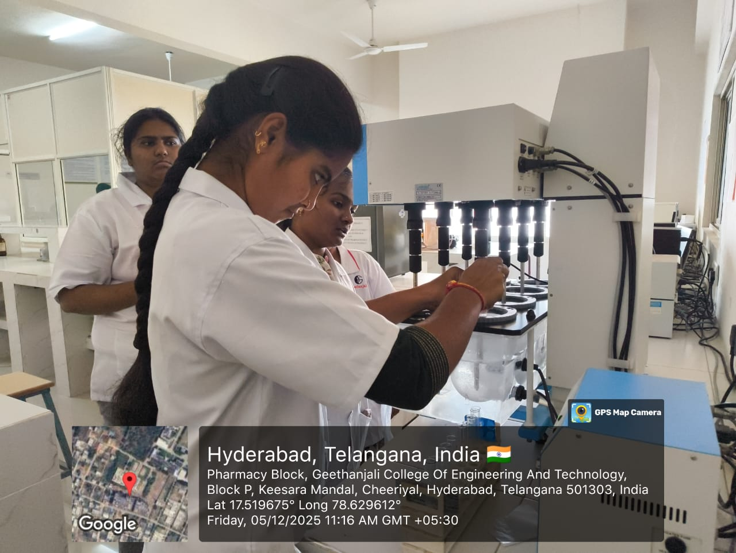

FACULTY HOD PRINCIPAL

Geethanjali College of Pharmacy
Approved by PCI New Delhi, Permanently Affiliated to JNTUH
Accredited by NBA (B. Pharmacy) & Accredited by NAAC (A+)
Recognized by DSIR-SIRO & HI/BI of MSME,Certified by ISO 9001:2015
Cheeryal (V), Keesara (M), Medchal-Malkajgiri Dist., Telangana State- 501303

PPT Presentations-Smart Board
Date: 04.04.2026
Name of the Faculty: Mrs. K. L. Rajitha Designation: Asst Professor
Department: Pharmaceutical Analysis
Subject: Pharmaceutical Biochemistry Class: B. Pharmacy I Year II sem
Unit /Topic: Citric Acid Cycle
Timings: 9:50 am to 10:40 am

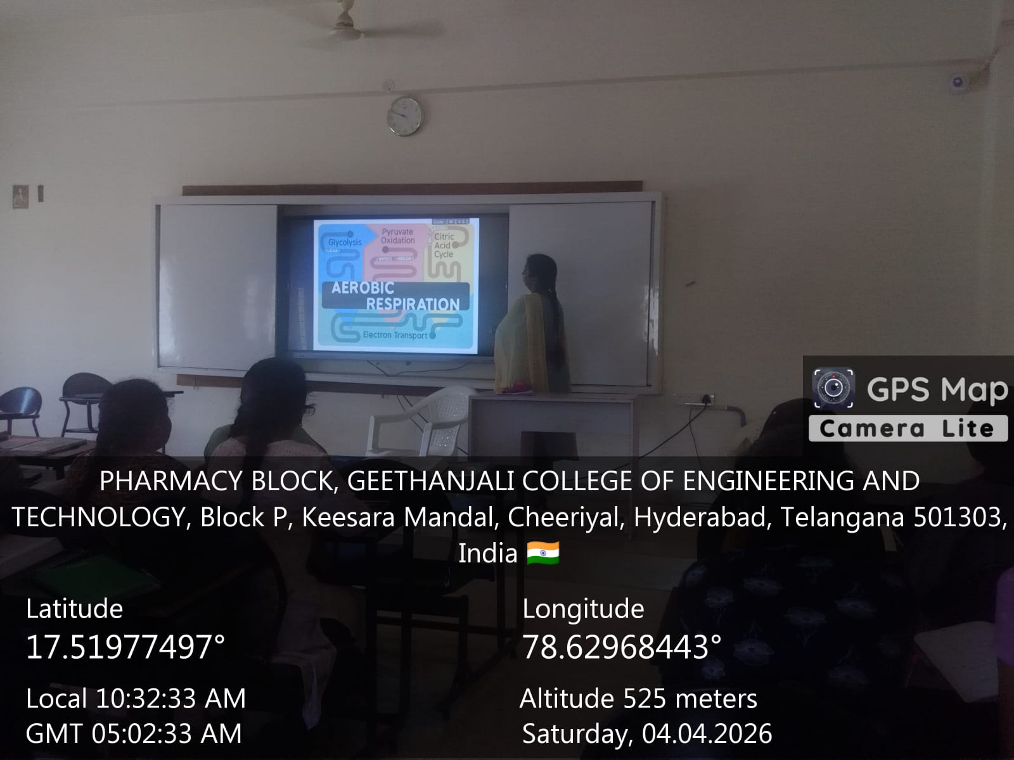

FACULTY HOD PRINCIPAL

Geethanjali College of Pharmacy
Approved by PCI New Delhi, Permanently Affiliated to JNTUH
Accredited by NBA (B. Pharmacy) & Accredited by NAAC (A+)
Recognized by DSIR-SIRO & HI/BI of MSME,Certified by ISO 9001:2015
Cheeryal (V), Keesara (M), Medchal-Malkajgiri Dist., Telangana State- 501303

Lab Demonstration-Model-based Learning
Date: 06.05.2026
Name of the Faculty: Mrs. R. Uma devi Designation: Associate Professor
Department: Pharmaceutical Chemistry
Subject: Pharmaceutical Organic Chemistry-I Lab Class: B. Pharmacy I Year II sem
Unit /Topic: Molecular Models
Timings: 12:10 pm to 3:20 pm

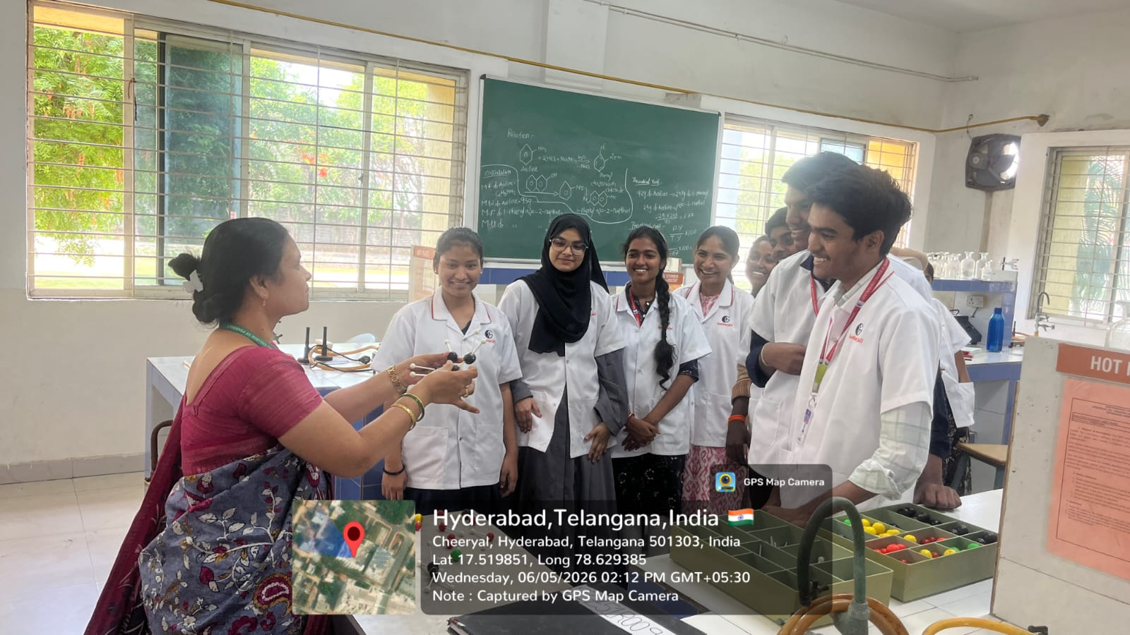

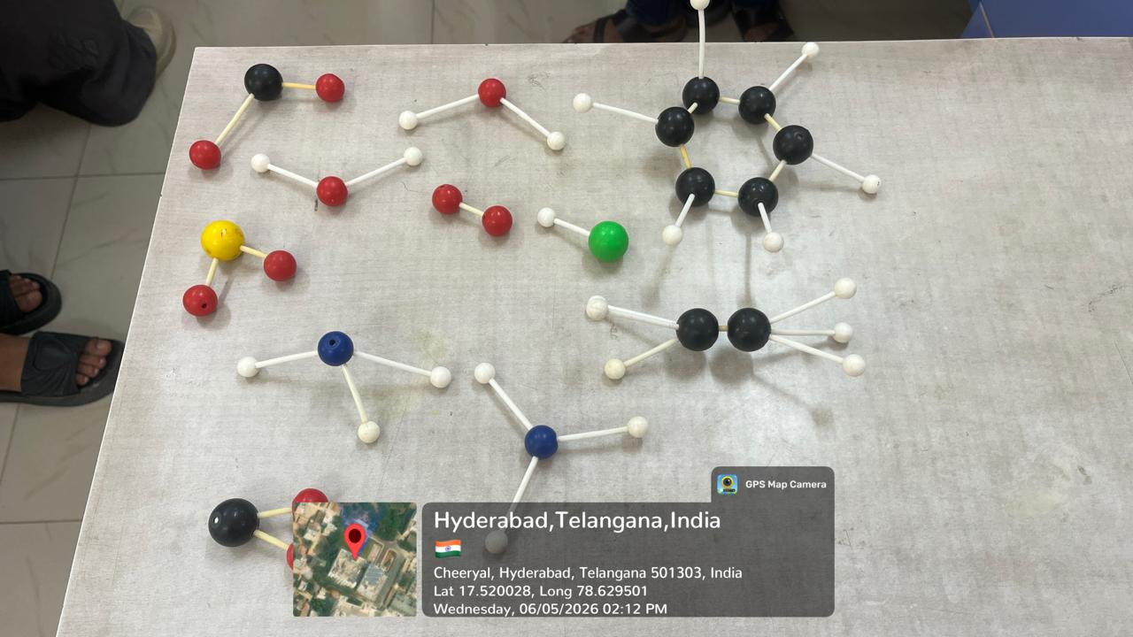

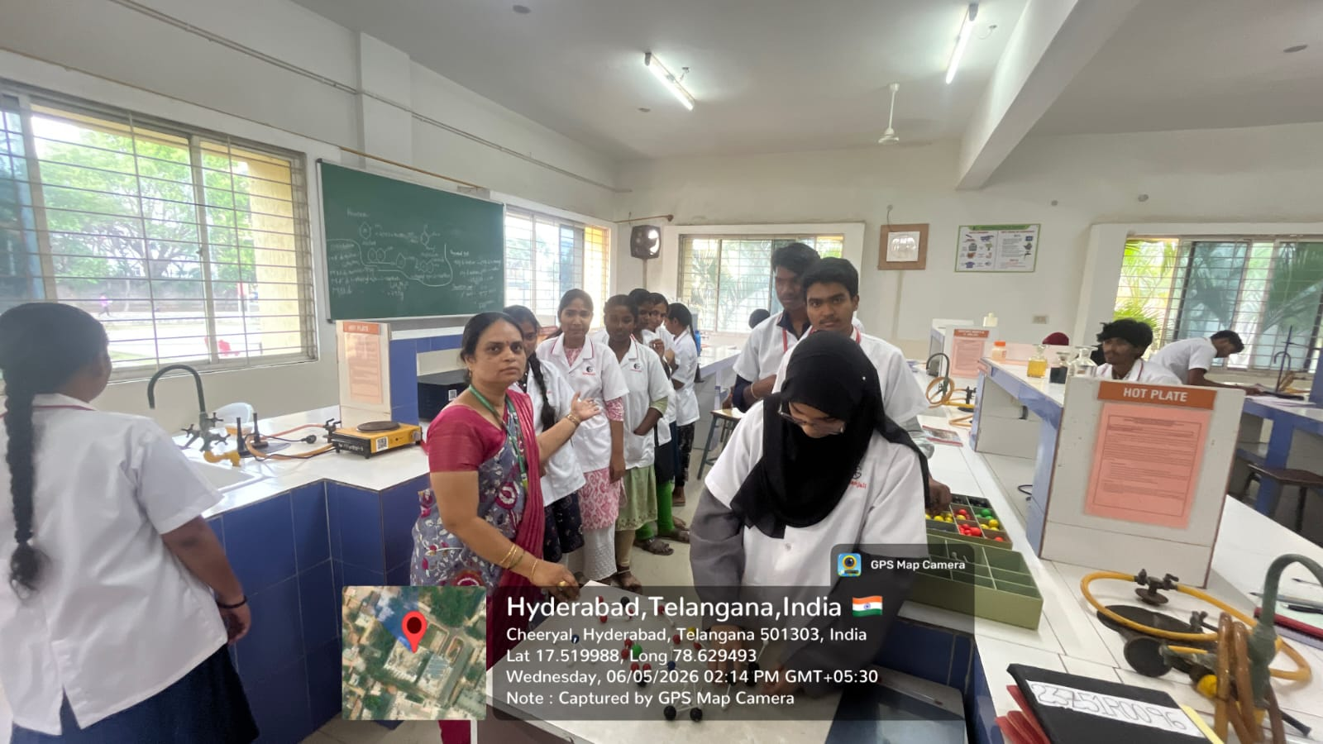

FACULTY HOD PRINCIPAL

Geethanjali College of Pharmacy
Approved by PCI New Delhi, Permanently Affiliated to JNTUH
Accredited by NBA (B. Pharmacy) & Accredited by NAAC (A+)
Recognized by DSIR-SIRO & HI/BI of MSME,Certified by ISO 9001:2015
Cheeryal (V), Keesara (M), Medchal-Malkajgiri Dist., Telangana State- 501303

Lab Demonstration-Youtube
Date: 07.04.2026
Name of the Faculty: Mrs. K. L. Rajitha Designation: Asst Professor
Department: Pharmaceutical Analysis
Subject: Pharmaceutical Biochemistry Lab Class: B. Pharmacy I Year II sem
Unit /Topic: Quantitative Analysis of Carbohydrates
Timings: 9:50 am to 10:40 am
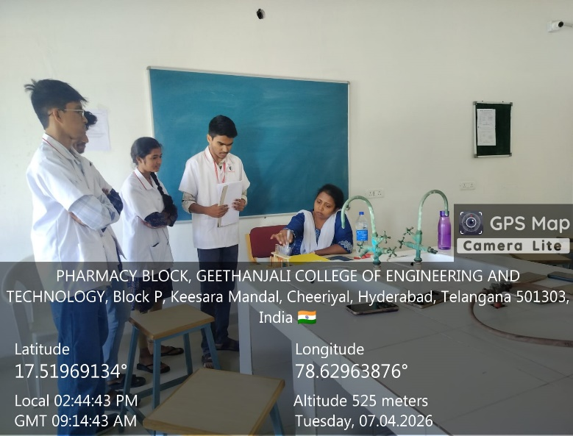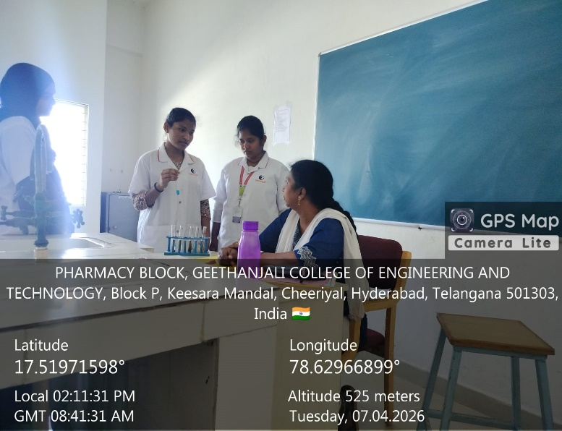

FACULTY HOD PRINCIPAL

Geethanjali College of Pharmacy
Approved by PCI New Delhi, Permanently Affiliated to JNTUH
Accredited by NBA (B. Pharmacy) & Accredited by NAAC (A+)
Recognized by DSIR-SIRO & HI/BI of MSME,Certified by ISO 9001:2015
Cheeryal (V), Keesara (M), Medchal-Malkajgiri Dist., Telangana State- 501303

Peer Teaching- Student Presentation (TLP method/ ICT Tool)
Date: 09.09.2025
Name of the Faculty: V. Shalini Designation: Asst Professor Department: Pharmacology
Presentation: Student Presentation
Subject: Pathophysiology Class: B.Pharmacy I Year II sem
Unit /Topic: Peptic Ulcer- Pathogenesis
Timings: 9:50 am to 10:40 am
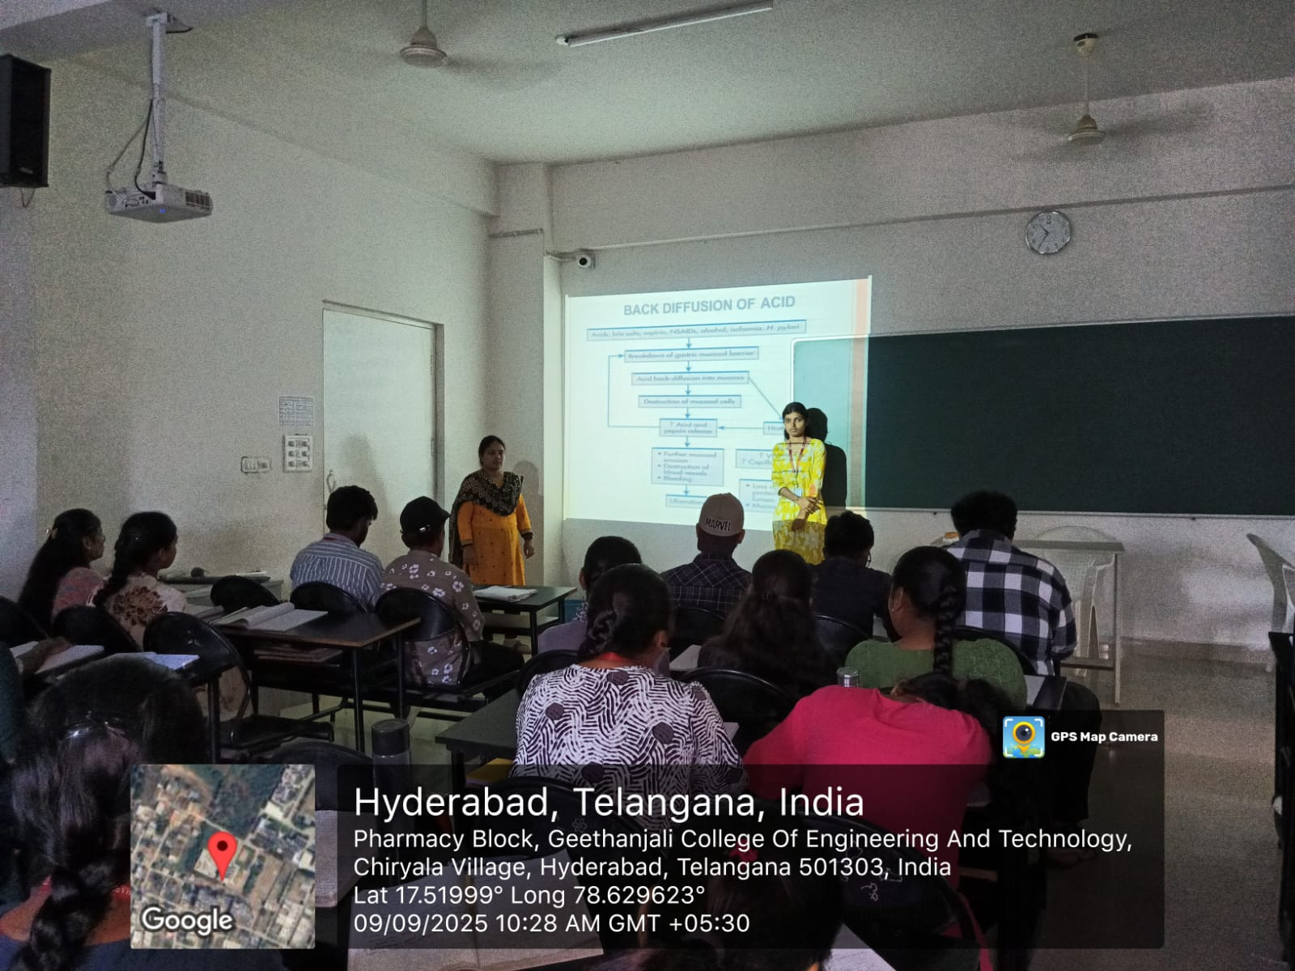

FACULTY HOD PRINCIPAL

Geethanjali College of Pharmacy
Approved by PCI New Delhi, Permanently Affiliated to JNTUH
Accredited by NBA (B. Pharmacy) & Accredited by NAAC (A+)
Recognized by DSIR-SIRO & HI/BI of MSME,Certified by ISO 9001:2015
Cheeryal (V), Keesara (M), Medchal-Malkajgiri Dist., Telangana State- 501303

Peer Teaching- Student Presentation (TLP method/ ICT Tool)
Date: 09.09.2025
Name of the Faculty: V. Shalini Designation: Asst Professor Department: Pharmacology
Presentation: Student Presentation
Subject: Pathophysiology Class: B.Pharmacy I Year II sem
Unit /Topic: Jaundice- Pathogenesis and Symptoms
Timings: 9:50 am to 10:40 am
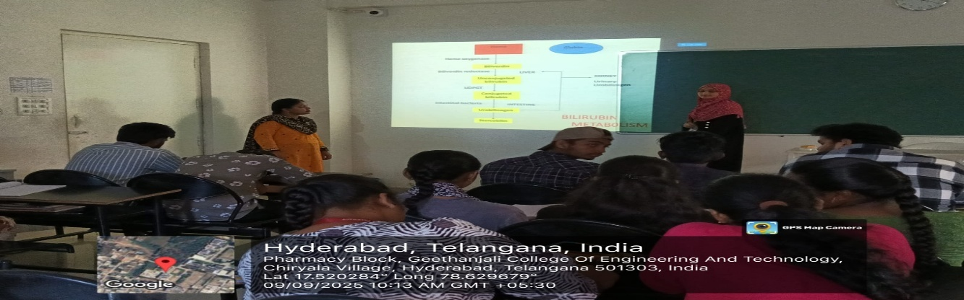
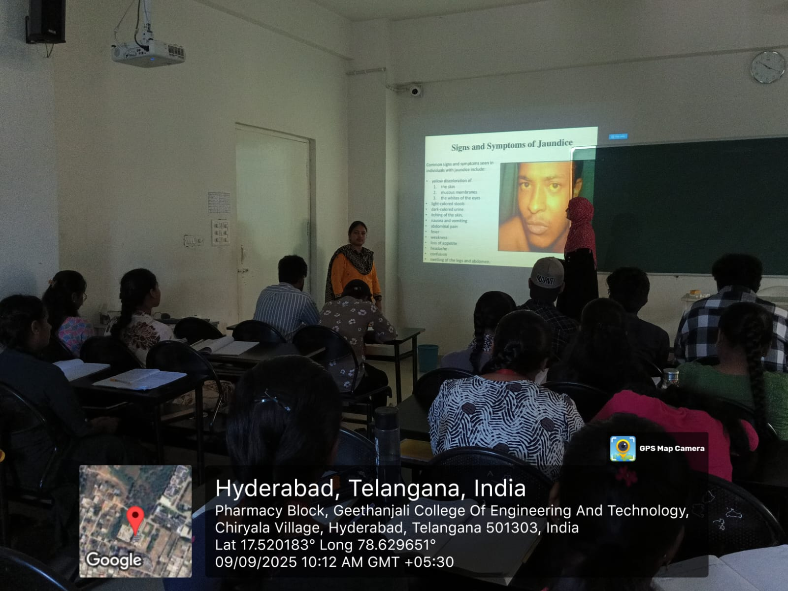

FACULTY HOD PRINCIPAL

Geethanjali College of Pharmacy
Approved by PCI New Delhi, Permanently Affiliated to JNTUH
Accredited by NBA (B. Pharmacy) & Accredited by NAAC (A+)
Recognized by DSIR-SIRO & HI/BI of MSME,Certified by ISO 9001:2015
Cheeryal (V), Keesara (M), Medchal-Malkajgiri Dist., Telangana State- 501303

Flowchart Presentation (TLP method/ ICT Tool)
Date: 30.07.2025
Name of the Faculty: V. Shalini Designation: Asst Professor Department: Pharmacology
Presentation: Flowchart Presentation
Subject: Pathophysiology Class: B.Pharmacy I Year II sem
Unit /Topic: Calcification- Pathogenesis
Timings: 10:40 am to 11:30 am
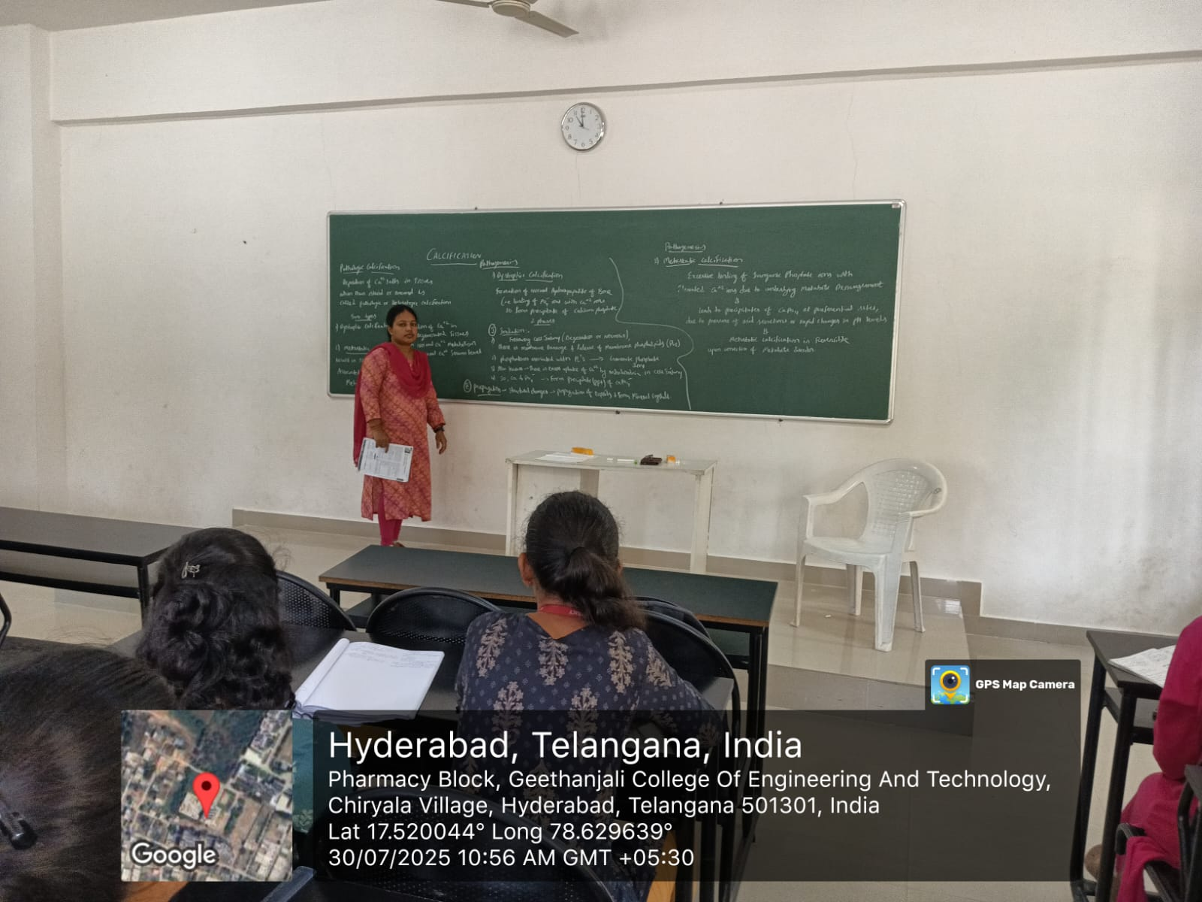

FACULTY HOD PRINCIPAL

Geethanjali College of Pharmacy
Approved by PCI New Delhi, Permanently Affiliated to JNTUH
Accredited by NBA (B. Pharmacy) & Accredited by NAAC (A+)
Recognized by DSIR-SIRO & HI/BI of MSME,Certified by ISO 9001:2015
Cheeryal (V), Keesara (M), Medchal-Malkajgiri Dist., Telangana State- 501303

Peer Teaching- Student Presentation (TLP method/ ICT Tool)
Date: 01.09.2025
Name of the Faculty: V. Shalini Designation: Asst Professor Department: Pharmacology
Presentation: Student Presentation
Subject: Pathophysiology Class: B.Pharmacy I Year II sem
Unit /Topic: Inflammatory Bowel Disease- Pathogenesis and Symptoms
Timings: 9:50 am to 10:40 am
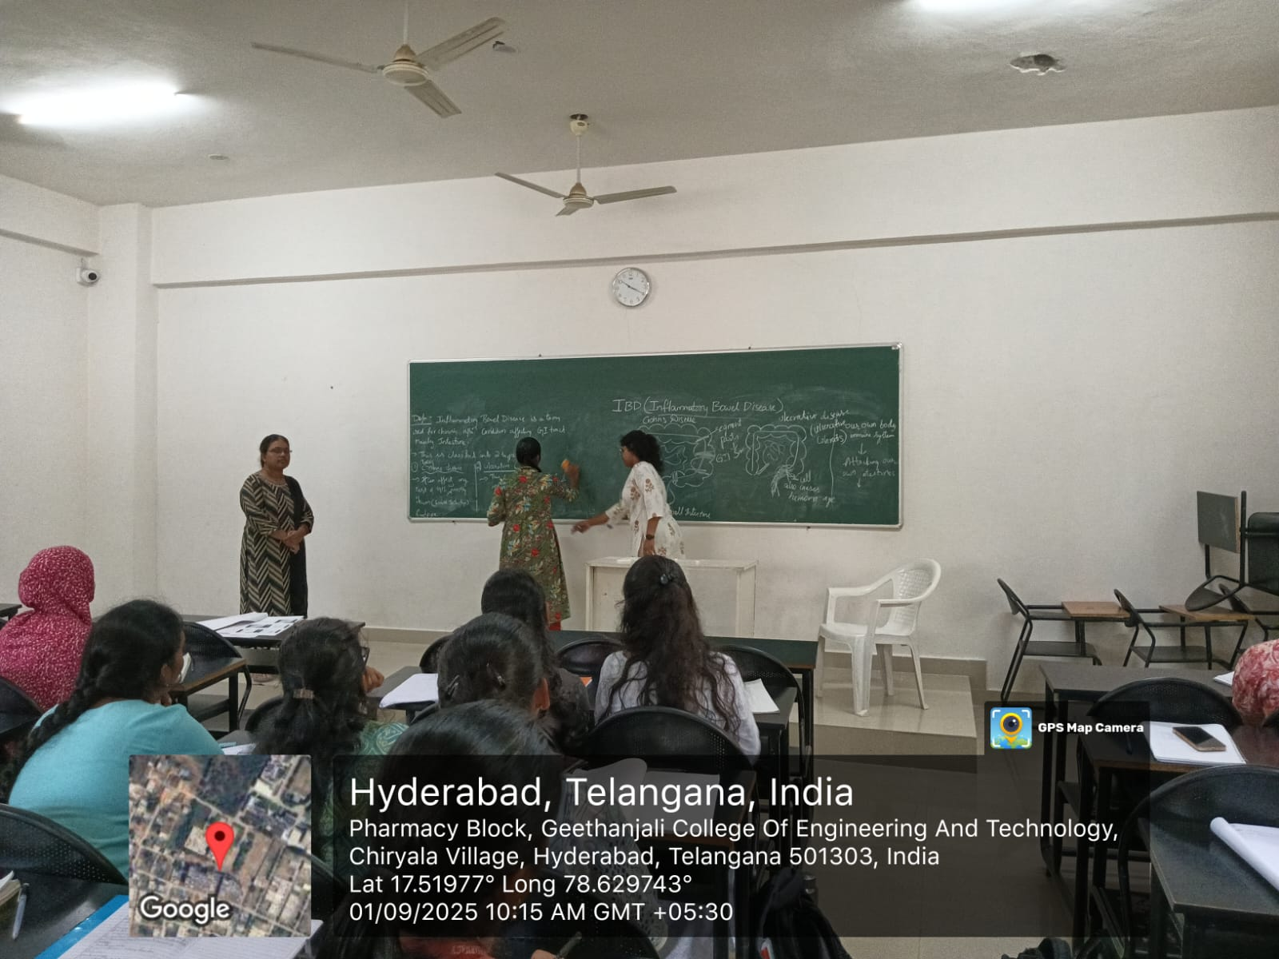
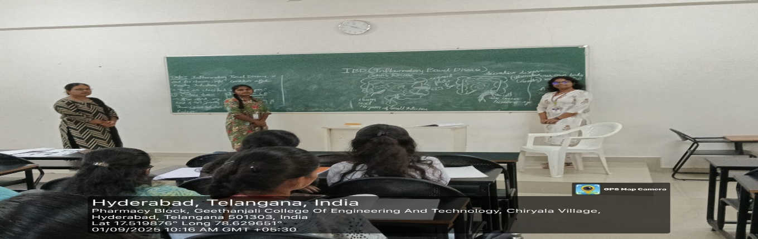
FACULTY HOD PRINCIPAL

Geethanjali College of Pharmacy
Approved by PCI New Delhi, Permanently Affiliated to JNTUH
Accredited by NBA (B. Pharmacy) & Accredited by NAAC (A+)
Recognized by DSIR-SIRO & HI/BI of MSME,Certified by ISO 9001:2015
Cheeryal (V), Keesara (M), Medchal-Malkajgiri Dist., Telangana State- 501303

PPT-Flowchart Presentation (TLP method/ ICT Tool)
Date: 29.07.2025
Name of the Faculty: V. Shalini Designation: Asst Professor Department: Pharmacology
Presentation: PPT- Flowchart Presentation
Subject: Pathophysiology Class: B.Pharmacy I Year II sem
Unit /Topic: Haemophilia – Types and Pathogenesis
Timings: 10:40 am to 11:30 am
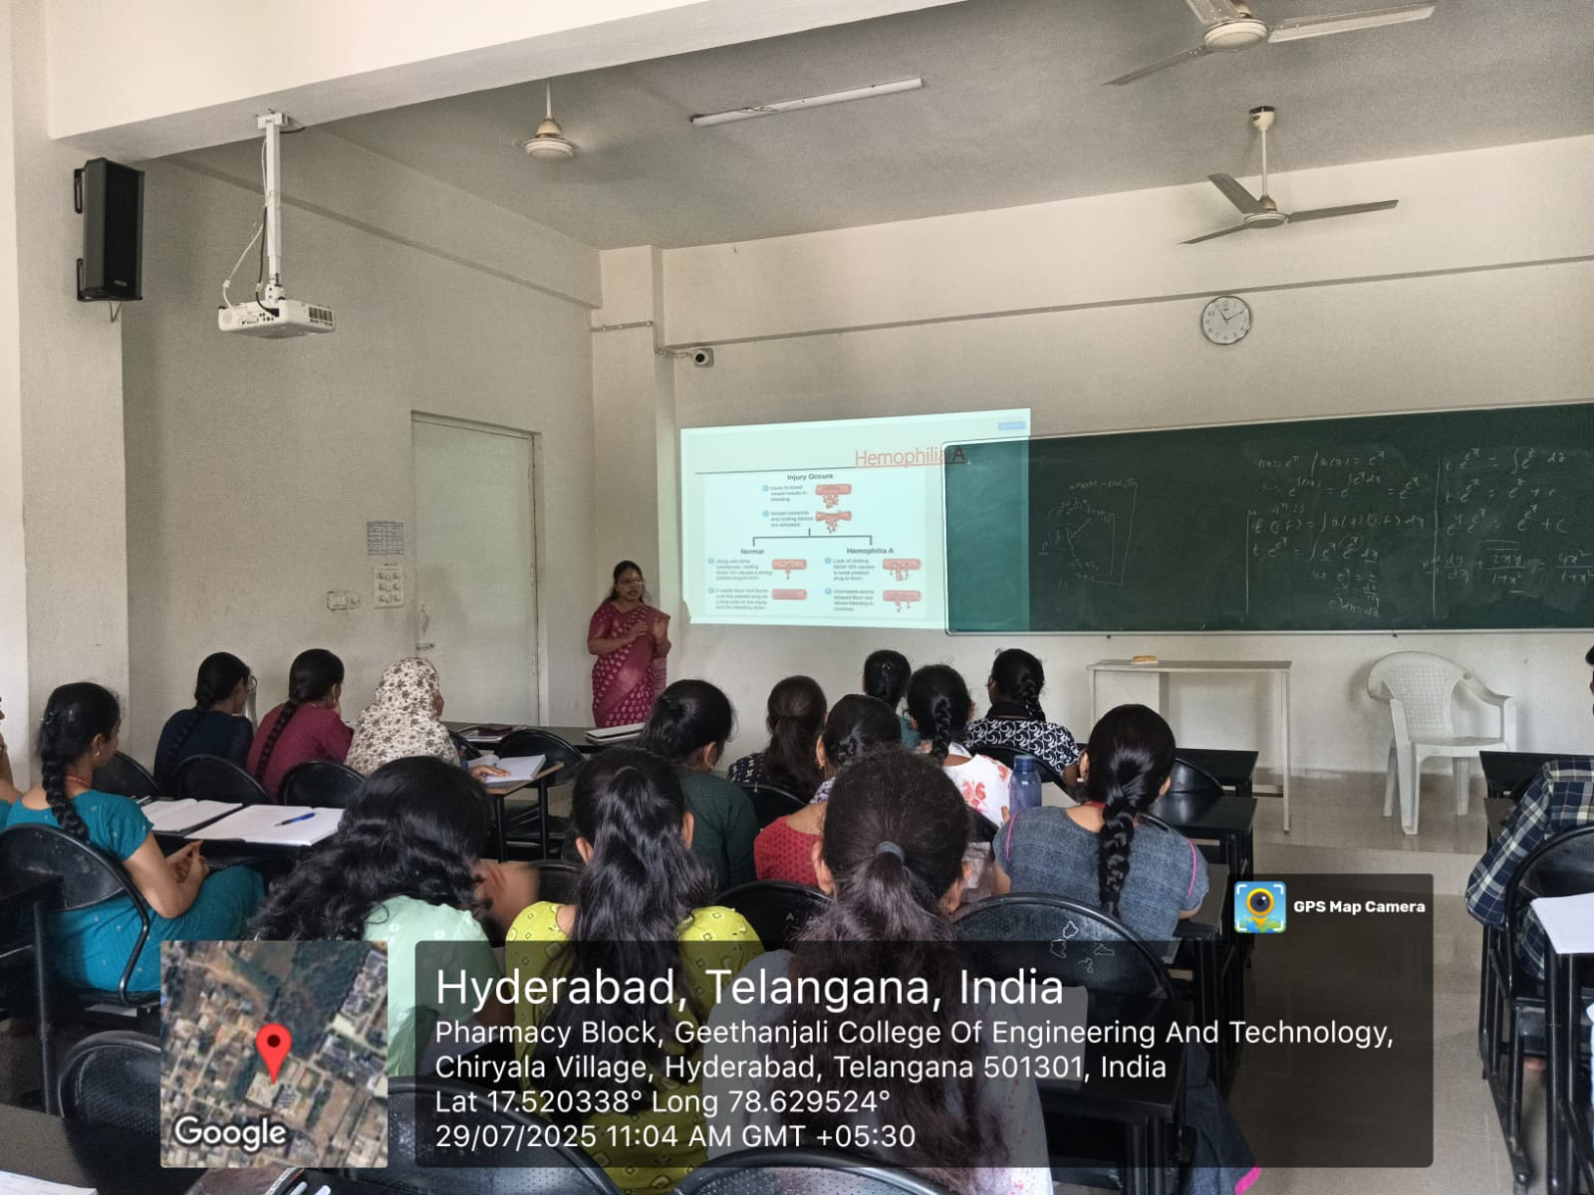

FACULTY HOD PRINCIPAL

Geethanjali College of Pharmacy

UGC AUTONOMOUS
Approved by PCI New Delhi, Affiliated to JNTUH, Accredited by NAAC with an A+ Grade,
Accredited by NBA (B. Pharmacy) Recognized by DSIR’s SIRO and ISO 9001:2015 Certified.
Cheeryal (V), Keesara (M), Medchal-Malkajgiri Dist.- Telangana State- 501303.

Blended Learning
Date: 30.07.2026
Name of the Faculty: Mrs. V. Shalini Designation: Associate Professor Department: Pharmacology
Presentation: PPT- Flowchart Presentation
Subject: Pathophysiology Class: B.Pharmacy I Year II sem
Unit /Topic: Amyloidosis
Timings: 10:40 am to 11:30 am
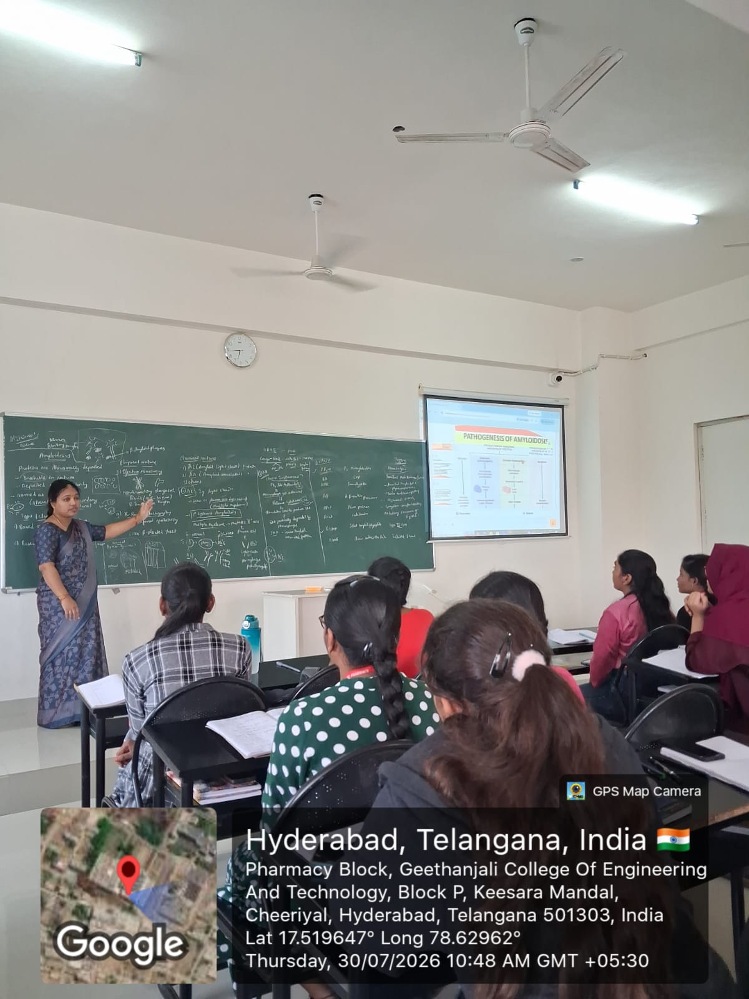
FACULTY HOD PRINCIPAL

Geethanjali College of Pharmacy

UGC AUTONOMOUS
Approved by PCI New Delhi, Affiliated to JNTUH, Accredited by NAAC with an A+ Grade,
Accredited by NBA (B. Pharmacy) Recognized by DSIR’s SIRO and ISO 9001:2015 Certified.
Cheeryal (V), Keesara (M), Medchal-Malkajgiri Dist.- Telangana State- 501303.
Problem based Learning -Smart Board
(ICT Enabled Teaching)
Date: 23.09.2026
Name of the Faculty: Mrs. B. Sandhya Designation: Asst Professor
Department: Pharmaceutical Chemistry
Presentation: Build the SAR Activity Structure Activity Relation (SAR)
Subject: Pathophysiology Class: B.Pharmacy IV Year I sem
Unit /Topic: Tetracycline Antibiotics
Timings: 1:00 pm to 1:50 pm
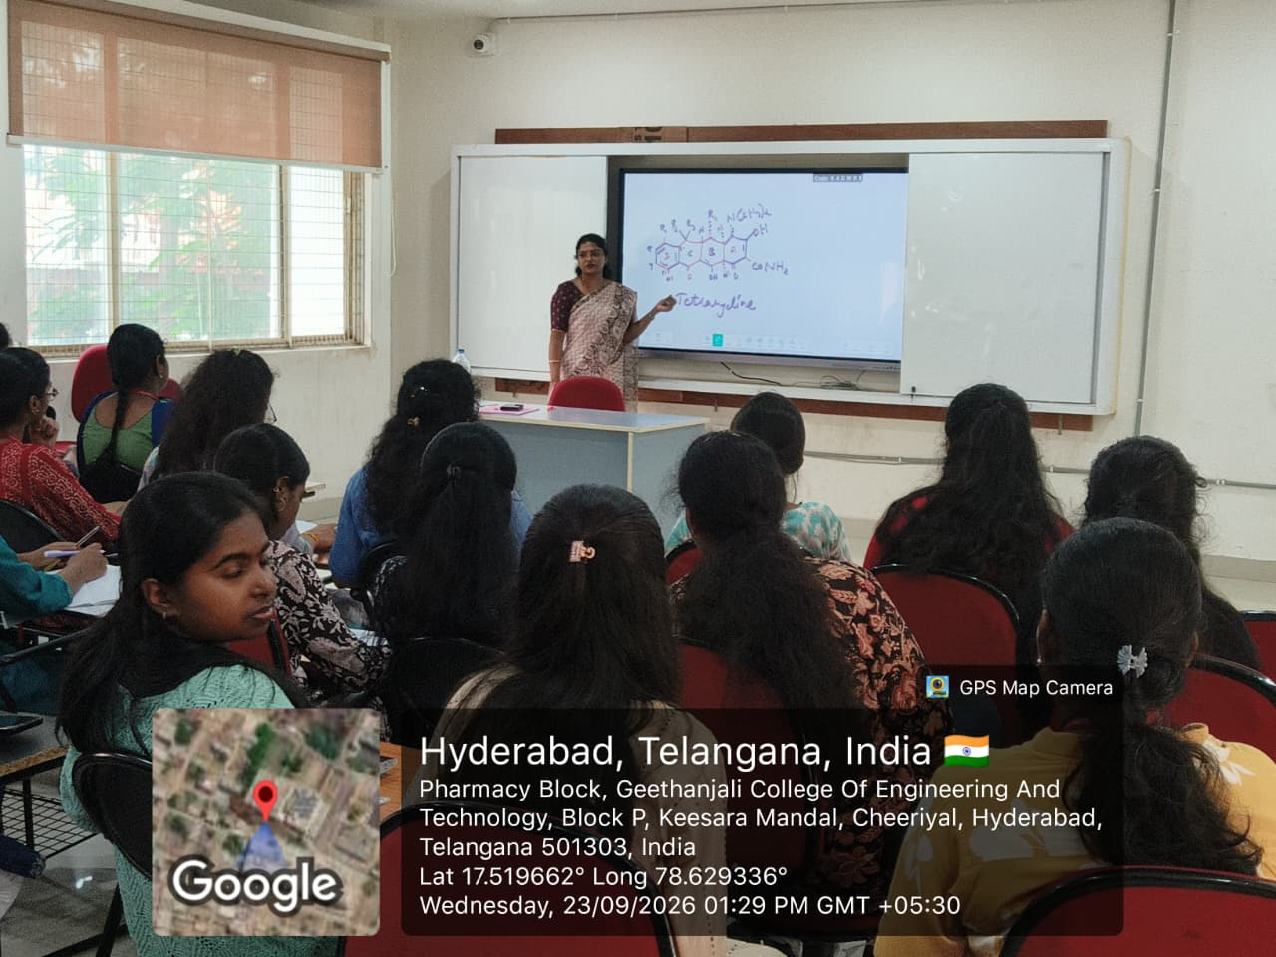

FACULTY HOD PRINCIPAL

